Hamilton County School-Based Adolescent Intensive Outpatient Program
Dana B. Holloway, Mikah Bradley, Ke’isha Bunion
Southern Adventist University
SOCW 612
Dr. Racovita

Abstract
Adolescent mental health and substance use needs in Hamilton County Schools continue to increase, while barriers such as transportation, affordability, long waitlists, and limited school-based staffing prevent many students from accessing timely and appropriate care. This proposal outlines the development of a school-based Intensive Outpatient Program (IOP) designed to provide flexible, evidence-based treatment for students ages 12-18 who require more support than traditional outpatient services but do not meet criteria for inpatient care. A mixed-methods needs assessment, including analysis of national and state Youth Risk Behavior Survey data, counselor-to-student ratios, and stakeholder feedback from school personnel, caregivers, and community mental health providers, guides the program’s design. The proposed IOP integrates group therapy, individual check-ins, family engagement, psychiatric support, and coordinated collaboration with school staff, supported by a stakeholder analysis, SWOT assessment, environmental scan, and comprehensive logic model. Expected outcomes include improved emotional regulation, increased coping skills, reduced behavioral referrals, enhanced academic engagement, and strengthened caregiver involvement. By embedding intensive treatment directly within schools, the program aims to reduce access barriers, improve student well-being, and serve as a sustainable and scalable model for supporting adolescent mental health in Hamilton County.
Keywords: adolescent mental health, school-based services, Intensive Outpatient Program, Hamilton County Schools, accessibility, behavioral health

Hamilton County School-Based Adolescent Intensive Outpatient Program
Adolescent mental health and substance use challenges have become a critical concern nationally and within Tennessee. Many youth experience depression, anxiety, trauma-related symptoms, and substance use that significantly interfere with their functioning, yet they do not consistently receive developmentally appropriate care. In Hamilton County, adolescents are affected by the same national trends, and the school system is directly impacted through increased behavioral referrals, absenteeism, and academic struggles. The proposed Hamilton County School-Based Adolescent Intensive Outpatient Program (IOP) aims to address these gaps by delivering intensive, evidence-based mental health and substance use services directly in school settings. The program is designed as a bridge between outpatient therapy and inpatient care, reducing access barriers and strengthening the connection between mental health and academic success (Kietzman et al., 2025).

Social Problem and Extent of Need
National Youth Risk Behavior Surveillance (YRBS) data show that a substantial proportion of high school students report persistent feelings of sadness or hopelessness and serious consideration of suicide (Centers for Disease Control and Prevention [CDC], 2023). Tennessee-specific YRBS data mirror these concerns, indicating that many adolescents in the state struggle with emotional distress, suicidal ideation, and related risk behaviors (Tennessee Department of Education, 2023). Untreated depression and other mental health conditions in adolescence are associated with higher risk of suicide attempts and long-term negative outcomes in education, employment, and social functioning. Despite the severity of these needs, access to appropriate care is limited. Many adolescents fall into a “care gap”: their symptoms are too severe for traditional once-weekly outpatient therapy, but they do not meet criteria for inpatient hospitalization. Intensive Outpatient Programs are designed to fill this level-of-care gap, but most existing IOPs are clinic-based. For families with limited transportation, inflexible work schedules, or financial stress, attending multiple weekly sessions at off-campus locations can be extremely difficult, even when the need is clear (Kietzman et al., 2025). Schools feel the impact of these unmet needs on a daily basis. Students with unaddressed mental health and substance use concerns are more likely to have behavioral referrals, disciplinary incidents, and chronic absenteeism. At the same time, school-based mental health staffing is stretched thin. The American School Counselor Association (ASCA) recommends a student-to-counselor ratio of 1:250, but many districts, including those similar to Hamilton County, operate closer to 1:400 or higher (American School Counselor Association, 2023). This combination, high student need and limited school mental health capacity, creates an urgent demand for accessible, intensive, school-connected services.
Target Population and Existing Services
The proposed program targets adolescents ages 12 to 18 enrolled in Hamilton County Schools who are experiencing moderate to severe mental health and/or substance use challenges that significantly interfere with their academic, social, or emotional functioning. These students may present with depression, anxiety, trauma-related symptoms, behavioral dysregulation, or co-occurring substance use. They require more intensive services than traditional outpatient therapy can offer, but they do not currently need inpatient hospitalization. The program is intended to serve a diverse student population across different genders, races and ethnicities, socioeconomic backgrounds, and family structures. Family engagement is viewed as a key component, and caregivers are invited to participate in regular check-ins and collaborative planning (Kietzman et al., 2025).
An environmental scan identified several agencies in Chattanooga and Hamilton County that provide mental health and substance use services to adolescents. Centerstone, McNabb Center, and Health Connect America are among the agencies that offer outpatient therapy, intensive outpatient services, family-based interventions, crisis services, and in some cases residential or inpatient treatment (Centerstone, n.d.; Health Connect America, n.d.; McNabb Center, n.d.). Additional agencies such as Time Wellness Centers, Agape Youth Behavioral, Embrace U, Journey Mental Health, Iris Wellness Group, Harmony Oaks Recovery Center, and CADAS offer combinations of outpatient, IOP, Partial Hospitalization Programs (PHP), and residential services for youth with mental health and co-occurring substance use needs (Agape Youth Behavioral, n.d.; Council for Alcohol & Drug Abuse Services, n.d.; Embrace U, n.d.; Harmony Oaks Recovery Center, n.d.; Iris Wellness Group, n.d.; Journey Mental Health, n.d.; Time Wellness Centers, n.d.).
However, most of these intensive services are clinic-based rather than school-based. That means adolescents and their families must find transportation, take time off work, and miss significant portions of the school day to attend treatment. These barriers contribute to inconsistent attendance, early program drop-out, or failure to initiate services at all, despite clear clinical needs.
Targeted Need
Among the many issues that contribute to the broader social problem, the specific targeted need identified is the integration of an Intensive Outpatient Program directly within Hamilton County Schools. While IOPs are designed to provide intensive, evidence-based treatment, their impact is limited when youth cannot attend consistently due to transportation and logistical challenges (Kietzman et al., 2025). By embedding IOP services in the school system, the program addresses access barriers at their source.
Integrating IOP into schools allows students to receive intensive mental health and substance use treatment while remaining in their home school environment. This model minimizes transportation needs, reduces the burden on caregivers, and supports continuity of care. It also offers the opportunity to connect therapeutic work with academic supports, creating a more holistic and coordinated approach to student well-being.
Literature Review and Evidence-Based Practices
National and state data consistently document rising rates of adolescent emotional distress, suicidal ideation, and related risk behaviors. The Youth Risk Behavior Survey (YRBS) indicates that a substantial proportion of high school students report persistent sadness or hopelessness and seriously consider suicide, underscoring the need for timely mental health intervention (Centers for Disease Control and Prevention [CDC], 2023). Tennessee-specific YRBS findings mirror these trends, suggesting that adolescents in Hamilton County are likely to experience similar patterns of distress and risk (Tennessee Department of Education, 2023). Untreated mental health needs during adolescence are associated with long-term negative outcomes in education, employment, and social functioning, which further justifies the development of school-connected intensive services (CDC, 2023; Tennessee Department of Education, 2023).
School-based mental health interventions have demonstrated positive effects on student well-being and academic engagement. A review of mental health interventions in schools in high-income countries found that school-based services can improve emotional and behavioral outcomes, particularly when programs are structured, evidence-based, and integrated into the school environment (Fazel et al., 2014). These findings support the idea that placing services where students already spend much of their time can reduce access barriers and increase engagement. Embedding intensive services, such as an Intensive Outpatient Program (IOP), within schools aligns with this evidence by delivering higher levels of care in a setting that is already familiar and accessible to students.
Empirical literature on adolescent IOPs emphasizes the importance of family involvement and structured, evidence-based modalities. Family-centered care approaches in adolescent intensive outpatient mental health treatment are associated with enhanced engagement and improved outcomes when programs actively involve caregivers and support communication between home and treatment settings (Kietzman et al., 2025). The proposed Hamilton County school-based IOP builds on this evidence by incorporating monthly caregiver check-ins and flexible family participation options.
The clinical components of the proposed program are grounded in well-established evidence-based practices. Cognitive Behavioral Therapy (CBT) and Dialectical Behavior Therapy (DBT) skills training have been widely used to address depression, anxiety, emotion dysregulation, and self-harm behaviors in adolescents, while Motivational Interviewing (MI) is commonly used to enhance readiness for change in youth with substance use concerns (Fazel et al., 2014; Kietzman et al., 2025). These modalities are especially effective in group formats, which are a core feature of many school-based and intensive outpatient programs. By integrating CBT, DBT skills, and MI into a structured, school-based IOP, the proposed program aligns with the empirical literature on effective adolescent mental health and substance use interventions while addressing local access barriers.
Problem Summary
Adolescents in Hamilton County Schools with moderate to severe mental health and substance use needs lack consistent access to intensive, developmentally appropriate services due to transportation, scheduling, and systemic barriers. As a result, many students fall into a “care gap” in which their symptoms are too severe for traditional outpatient therapy but do not meet criteria for inpatient hospitalization, leading to unmet treatment needs, increased behavioral referrals, and academic disruption (CDC, 2023; Kietzman et al., 2025; Tennessee Department of Education, 2023).
Need for the Program
The need for a school-based adolescent IOP is identified through multiple converging data sources. National and Tennessee YRBS data document significant rates of emotional distress, suicidal ideation, and substance use among high school students (CDC, 2023; Tennessee Department of Education, 2023). Locally, Hamilton County Schools report behavioral incidents, chronic absenteeism, and academic struggles that align with these broader trends. Existing community mental health agencies provide outpatient and intensive services, but clinic-based IOP models require families to navigate transportation, time off work, and long waitlists, which limit consistent participation (Centerstone, n.d.; Health Connect America, n.d.; McNabb Center, n.d.). The proposed school-based IOP fills these gaps by bringing intensive services directly to school campuses, reducing logistical barriers, and aligning clinical intervention with educational settings.
Statement of Purpose
The purpose of the needs assessment is to systematically document unmet adolescent mental health and substance use needs in Hamilton County Schools, identify barriers to accessing existing services, and evaluate the perceived feasibility and acceptability of a school-based Intensive Outpatient Program model among key stakeholders. This information will guide program design and implementation to ensure that the proposed IOP responds directly to local conditions and stakeholder priorities.
Research Questions
The needs assessment is guided by the following research questions:
- What unmet mental health and substance use needs do students in Hamilton County Schools experience?
- What barriers do students, caregivers, and school personnel identify in accessing existing mental health and substance use services?
- How do school staff, caregivers, and community mental health providers perceive the feasibility and potential impact of a school-based adolescent IOP?
- What structural and logistical factors (e.g., scheduling, space, staffing) influence the implementation of a school-based IOP in Hamilton County Schools?
Research Hypotheses
For the quantitative component of the needs assessment, the following hypotheses will be explored:
- Students with higher levels of self-reported emotional distress and substance use will be more likely to report unmet needs for mental health or substance use treatment.
- Students and caregivers who report transportation and scheduling barriers will be less likely to have engaged in clinic-based IOP or other intensive services.
- School staff who report higher rates of behavioral referrals and absenteeism will express greater support for a school-based IOP model.
Research Variables and Concepts
Key quantitative variables will include indicators such as self-reported emotional distress, suicidal ideation, substance use behaviors, prior service use, perceived barriers (e.g., transportation, cost, scheduling), and school-level indicators such as behavioral referrals and attendance patterns (CDC, 2023; Tennessee Department of Education, 2023). Qualitative concepts will include perceived need, feasibility, acceptability, and stakeholder perspectives on school-based intensive services.
Methodology
A mixed-methods approach will be used to capture both the scope of the need and the depth of stakeholder perspectives. Quantitative data will be gathered through brief survey instruments administered to school staff and, if feasible, to students and caregivers. Qualitative data will be collected through semi-structured interviews and focus groups with school personnel, caregivers, and community mental health providers. A mixed-methods design is appropriate because it integrates numerical indicators of need with contextual insights about barriers and feasibility, providing a more comprehensive basis for program planning (Creswell & Plano Clark, 2018).
Population and Sampling (see Appendix D)
The target population for the needs assessment includes school personnel (e.g., principals, school social workers, counselors), caregivers of students with identified behavioral or emotional concerns, and representatives from community mental health agencies that serve Hamilton County youth. Convenience and purposive sampling will be used to recruit participants from selected middle and high schools and partnering agencies. School district approval and, if applicable, Institutional Review Board review will be sought prior to data collection.
Data Collection and Analysis Plan (see Appendix D)
Quantitative data will be collected using brief electronic or paper surveys that assess perceived student needs, current referral patterns, and barriers to service access. Descriptive statistics will be used to summarize the frequency and distribution of reported needs and barriers, and simple comparative analyses (e.g., cross-tabulations) may be used to explore patterns across school sites or stakeholder groups (Creswell & Plano Clark, 2018).
Qualitative data will be collected through semi-structured interviews and focus groups with school staff, caregivers, and community providers. Interviews and focus groups will be audio-recorded with consent and transcribed for analysis. A thematic analysis approach will be used to identify recurring themes related to unmet needs, barriers, feasibility, and recommendations for program design (Fazel et al., 2014). Integrating quantitative and qualitative findings will help ensure that the school-based IOP is grounded in both measurable need and lived experience.
Ethical Considerations
Because the needs assessment involves sensitive topics and may include information about minors’ mental health and substance use, careful attention will be given to ethical considerations. Participation will be voluntary, and informed consent will be obtained from adult participants, with parental consent and youth assent required for any direct student participation. Confidentiality will be protected by de-identifying data and securely storing all records. Participants will be reminded that they may decline to answer any questions or withdraw at any time without penalty. When possible, information about local mental health resources will be provided to participants who express distress or request support. These steps are essential to protect vulnerable populations and maintain trust with schools and families (Creswell & Plano Clark, 2018; Fazel et al., 2014).
Program Description
The Hamilton County School-Based Adolescent Intensive Outpatient Program is designed as a school-embedded IOP serving students ages 12–18 who exhibit moderate to severe mental health or co-occurring substance use concerns that impair their functioning but do not require inpatient hospitalization. The program functions as a bridge between outpatient and inpatient care, providing structured, intensive services while keeping students in their school communities.
The IOP will operate three to four days per week on selected school campuses. To minimize academic disruption, services will be delivered in shorter blocks across the school day and after school rather than in a single long session. A typical schedule might include a one-hour therapeutic group during an elective period, a 30–45 minute structured lunch session, and an additional hour of group or skills work after school. This structure preserves treatment intensity while allowing students to remain engaged in core academic classes.
The clinical approach is grounded in evidence-based modalities commonly used with adolescents in intensive settings. Interventions will include Cognitive Behavioral Therapy (CBT), Dialectical Behavior Therapy (DBT) skills training, and Motivational Interviewing (MI), combined with psychoeducation on emotional regulation, coping skills, healthy relationships, and substance use prevention. These interventions have been shown to reduce symptoms and improve functioning when delivered in a structured, consistent format (Fazel et al., 2014; Kietzman et al., 2025).
Family involvement is built into the program design. Caregivers are encouraged to participate in monthly collaborative check-ins, and the program provides flexible options for engagement (in person, by phone, or virtually) to reduce barriers. A multidisciplinary team, which may include licensed clinicians, case managers, and psychiatric providers, will deliver services and coordinate with school staff. This coordination ensures that therapeutic goals are aligned with behavioral supports and academic plans for each student.
Program Uniqueness
The proposed school-based IOP differs from existing services in several important ways. First, it locates intensive treatment directly in the school environment, which significantly reduces barriers related to transportation and scheduling. Rather than having to travel to a clinic for several hours at a time, students can access intensive services on campus during the school day and immediately after school.
Second, the program uses a flexible block scheduling model. Traditional IOPs often require three consecutive hours per day or full-day participation, which can be incompatible with academic demands. In contrast, this program distributes the required treatment hours across multiple shorter blocks, allowing students to maintain participation in their core classes while still receiving intensive support.
Third, the program emphasizes integration with school-based supports. Because clinicians are embedded in the school environment, they can develop close working relationships with counselors, teachers, and administrators. This allows for more timely communication, better alignment of intervention strategies, and coordinated responses to crises or academic difficulties.
Finally, the program explicitly blends evidence-based clinical interventions with family collaboration. By combining CBT, DBT skills, and Motivational Interviewing with regular caregiver check-ins, the program supports skill generalization across school and home contexts (Kietzman et al., 2025). Together, these features create a unique level-of-care option that is not currently available in Hamilton County.
Program Goals
The program is guided by two primary goals. The first goal is to increase access to intensive, evidence-based mental health and substance use treatment for adolescents in Hamilton County Schools who might otherwise be unable to engage in such services due to logistical and financial barriers. The second goal is to improve emotional well-being and school functioning for participating students, including reductions in behavioral incidents, greater use of healthy coping skills, and improved academic engagement.
These goals are directly linked to the documented prevalence of adolescent mental health needs and the clear service gaps described in national, state, and local data (CDC, 2023; Tennessee Department of Education, 2023). They also reflect the program’s dual focus on clinical improvement and educational success.
SWOT Analysis (see Appendix A and B)
Strengths
The proposed school-based IOP has several strengths. It is grounded in evidence-based practices (CBT, DBT skills, MI) and a family-centered approach that aligns with the literature on effective adolescent intensive services (Fazel et al., 2014; Kietzman et al., 2025). Locating the program in schools reduces transportation and scheduling barriers and allows for close coordination with school staff, which addresses well-documented access issues (CDC, 2023). The program’s flexible block scheduling model is designed to preserve instructional time while providing intensive support. These strengths can be leveraged by highlighting the evidence base and practical benefits when engaging stakeholders and funders.
Weaknesses
Potential weaknesses include the need for dedicated space on school campuses, the challenge of recruiting and retaining qualified clinical staff, and the complexity of coordinating schedules within the school day. Start-up costs for staffing, training, and materials may be high. These weaknesses can be mitigated by piloting the program at a limited number of schools, using shared or multipurpose spaces, phasing in services, and developing partnerships with community mental health agencies to share staffing and supervision (Centerstone, n.d.; McNabb Center, n.d.).
Opportunities
There are multiple opportunities that support the development of a school-based adolescent IOP. Increased national attention to youth mental health, the availability of grant funding for school-based services, and an emphasis on improving school climate and safety create a favorable policy context (CDC, 2023; Tennessee Department of Education, 2023). Partnerships with community mental health agencies and youth-serving organizations present additional opportunities for joint programming, staff training, and coordinated referrals. These opportunities can be exploited by proactively seeking grants, formalizing memoranda of understanding with partners, and aligning program outcomes with district and state priorities.
Threats
Threats to the program include potential budget cuts, changes in district leadership or policy priorities, staff turnover, and competing demands on school time and resources. High student-to-counselor ratios and existing workload demands may make it difficult for school staff to fully engage with the program (American School Counselor Association, 2023). To defend against these threats, the program will emphasize data-driven outcomes, maintain regular communication with district leadership, build redundancy into staffing plans, and demonstrate how the IOP supports, not competes with, academic goals.
Stakeholder Analysis (see Appendix A)
The success of the Hamilton County School-Based Adolescent IOP depends on meaningful engagement with multiple stakeholders who influence or are affected by the program. Primary stakeholders include students, parents and caregivers, Hamilton County Board of Education and district leadership, school personnel, community mental health partners, and faith-based or community youth organizations. Each group brings unique interests, expectations, and concerns that must be addressed for the program to be feasible and sustainable.
Students ages 12–18 who experience mental health or substance use challenges are the central stakeholders. They are primarily interested in confidential, accessible, and youth-centered services that respect their dignity and reduce stigma. Some students may fear being labeled or judged if they participate in an intensive program at school, which underscores the need for trauma-informed, inclusive engagement strategies and clear communication about privacy protections (CDC, 2023; Fazel et al., 2014).
Parents and caregivers seek support that improves their child’s emotional and academic functioning while preserving safety and family stability. They may worry about being judged or blamed, or about how information from the program will be shared with school personnel. Providing flexible family engagement options, clear communication about confidentiality, and regular updates about student progress can help build trust and foster collaboration (Kietzman et al., 2025).
Hamilton County Board of Education members and district-level leaders hold high power and interest in the program’s success. They are concerned with student outcomes, legal and policy compliance, fiscal responsibility, and long-term sustainability. Demonstrating a strong evidence base, clear alignment with district priorities, and a realistic resource plan will be crucial to securing and maintaining their support (American School Counselor Association, 2023; Tennessee Department of Education, 2023).
School personnel, including principals, school social workers, counselors, and teachers, are essential partners in day-to-day implementation. They may welcome additional support for students with significant needs but also fear increased workload or role confusion. Engaging school staff in planning, clarifying roles and responsibilities, and providing ongoing training can help ensure that the IOP is experienced as a resource rather than a burden (Fazel et al., 2014).
Community mental health partners, such as Centerstone, McNabb Center, and Health Connect America, may initially worry about duplication of services or competition. However, they also stand to benefit from improved collaboration, clearer referral pathways, and opportunities for shared staffing and supervision (Centerstone, n.d.; Health Connect America, n.d.; McNabb Center, n.d.). Finally, faith-based and community youth organizations, such as church coalitions or the local YMCA, can support outreach, after-school programming, and community education, provided that partnerships are grounded in mutual respect and clarity about roles.
By intentionally identifying, engaging, and communicating with these stakeholders, the program can build a coalition of support that strengthens implementation, evaluation, and sustainability.
Main Activities
To achieve its goals, the program will implement several key activities. Adolescents identified as appropriate for the IOP will participate in three to four days of services per week on their school campus. Each treatment day will include structured therapeutic groups and skills sessions based on CBT, DBT skills training, and Motivational Interviewing. These groups will focus on topics such as managing strong emotions, challenging unhelpful thoughts, building healthy relationships, increasing motivation for change, and reducing risky behaviors.
In addition to group therapy, the program will provide psychoeducation on stress management, trauma, and substance use, helping students understand how these issues affect their bodies, minds, and relationships. Family involvement will be facilitated through monthly collaborative meetings with caregivers, during which progress, challenges, and goals are reviewed. The clinical team will also coordinate regularly with school counselors, teachers, and administrators to ensure that interventions are aligned with academic and behavioral expectations and to address barriers to participation as they arise.
These activities are designed to be intensive enough to produce meaningful change while remaining feasible within the daily operations of the school.
Proposed Program Resources (see Appendix C)
Successful implementation of the Hamilton County School-Based Adolescent IOP will require adequate human, material, and organizational resources. Human resources include a multidisciplinary clinical team composed of licensed mental health clinicians (e.g., LCSWs, LPCs), a part-time or consulting psychiatric provider (e.g., psychiatrist or psychiatric nurse practitioner), and a case manager or care coordinator. Administrative support will be needed for scheduling, data entry, and communication with families and school staff. Whenever possible, staffing partnerships with existing community mental health agencies can help share personnel and supervision responsibilities (Centerstone, n.d.; Health Connect America, n.d.; McNabb Center, n.d.).
Material resources include confidential meeting space on school campuses for group sessions and individual check-ins, such as a designated counseling room and access to a larger room for group activities. The program will also require basic office equipment, secure storage for records, computers with access to electronic health record or documentation systems, and printed materials such as psychoeducational handouts and consent forms. Access to secure telehealth platforms may be helpful for caregiver meetings or psychiatric consultations when in-person attendance is not feasible.
Organizational resources involve formal agreements with the school district that clarify roles, responsibilities, and use of space, as well as memoranda of understanding with partner agencies. Ongoing training in trauma-informed care, cultural responsiveness, and evidence-based interventions will be necessary to maintain program quality over time (Fazel et al., 2014; Kietzman et al., 2025). Together, these resources provide the foundation needed for the IOP to operate effectively and ethically within Hamilton County Schools.
Evaluation Plan
Evaluation is an essential component of the proposed program. A mixed-methods, quasi-experimental pre–post design will be used to assess program impact. Quantitatively, the program will track behavioral referrals for participating students before and after involvement in the IOP. Additional indicators such as suspensions and attendance patterns may also be monitored. Comparing data from the semester prior to participation with data from the semester following participation will help determine whether the program is associated with reductions in behavioral incidents and related concerns.
Qualitative data will be gathered through focus groups and interviews with students, caregivers, and school staff. These conversations will explore perceived changes in emotional regulation, behavior, academic engagement, and family functioning, as well as experiences of barriers and facilitators to participation. Collecting both quantitative and qualitative data will provide a more complete understanding of program effectiveness and will help identify areas for ongoing refinement (Creswell & Plano Clark, 2018; Fazel et al., 2014).
Sustainability Plan
Long-term sustainability has been considered from the outset of program planning. The sustainability plan focuses on building strong partnerships with Hamilton County Schools and with community mental health agencies. Formal agreements with the school district will clarify roles, responsibilities, and resource commitments, increasing the likelihood that the program can be maintained over time.
Program data will be used to demonstrate effectiveness, providing a basis for ongoing district investment and potential integration into existing funding streams. Collaboration with agencies such as Centerstone, McNabb Center, and Health Connect America may support shared staffing, supervision, and training, further strengthening sustainability (Centerstone, n.d.; Health Connect America, n.d.; McNabb Center, n.d.). Additionally, the program will seek diversified funding sources, including state and federal grants and private foundations, to reduce dependence on any single funding stream.
Lessons Learned
Several lessons emerged during the development of the Hamilton County School-Based Adolescent IOP. First, conducting a thorough needs assessment using national, state, and local data helped keep the program grounded in real conditions rather than assumptions. Recognizing the extent of adolescent distress and the gaps in existing services confirmed that a school-based IOP is not only innovative but necessary (CDC, 2023; Tennessee Department of Education, 2023).
Second, the process underscored that access matters as much as intervention quality. Even the most evidence-based treatment model cannot be effective if students cannot reach it. Locating IOP services within schools directly addresses barriers such as transportation and scheduling that have historically limited participation in clinic-based programs.
Third, the importance of flexibility and feasibility became clear. Designing a program that is both clinically intensive and compatible with school schedules required creativity and collaboration, particularly around block scheduling and coordination with academic staff.
Fourth, the team recognized that evaluation is an ethical responsibility. Tracking outcomes and gathering stakeholder feedback is necessary not only for funding but also for ensuring that the program truly benefits the students it is meant to serve.
Finally, the project highlighted that program development is macro-level practice with a micro-level impact. Decisions about program design, location, funding, and partnerships shape the everyday reality of whether individual students receive meaningful help. In this sense, administrative and policy work are directly connected to clinical outcomes (Kietzman et al., 2025).
Limitations
This program proposal has several limitations that should be acknowledged. First, the needs assessment and program design are based on available national, state, and local data, as well as anticipated stakeholder feedback; actual implementation may reveal additional needs or barriers that were not fully captured in preliminary planning (CDC, 2023; Tennessee Department of Education, 2023). Second, the proposed IOP model assumes sufficient district support, school space, and availability of qualified clinical staff, all of which may be affected by budget constraints, workforce shortages, or policy changes. Third, while the mixed-methods evaluation plan is designed to capture meaningful outcomes, it may not include comparison groups or long-term follow-up, which limits the ability to draw causal conclusions or assess durability of effects (Creswell & Plano Clark, 2018). Finally, as a pilot initiative, the program may initially serve a limited number of schools and students, which could affect generalizability to the entire district. These limitations highlight the importance of ongoing evaluation, flexibility, and stakeholder engagement as the program is implemented and refined.
Conclusion
The Hamilton County School-Based Adolescent Intensive Outpatient Program is a response to the serious and growing mental health and substance use needs of adolescents in the district. By embedding IOP services within schools, the program aims to reduce access barriers, provide intensive, evidence-based treatment, and support improved behavioral and academic outcomes. Guided by data, shaped by the literature, and grounded in collaboration with schools and community providers, this program represents a realistic and forward-thinking strategy to support adolescent well-being in Hamilton County.

References
Agape Youth Behavioral. (n.d.). Agape Youth Behavioral. http://youthbehavior.com/
American School Counselor Association. (2023). Student-to-school counselor ratio 2022–2023. https://www.schoolcounselor.org
Centers for Disease Control and Prevention. (2023). Youth Risk Behavior Survey data summary and trends report: 2011–2021. U.S. Department of Health and Human Services.
Centerstone. (n.d.). Centerstone Tennessee services. https://centerstone.org
Council for Alcohol & Drug Abuse Services. (n.d.). Youth services. https://www.cadas.org
Creswell, J. W., & Plano Clark, V. L. (2018). Designing and conducting mixed methods research (3rd ed.). SAGE.
Embrace U. (n.d.). Embrace U – Chattanooga, TN. https://www.embraceu.com
Fazel, M., Hoagwood, K., Stephan, S., & Ford, T. (2014). Mental health interventions in schools in high-income countries. The Lancet Psychiatry, 1(5), 377–387.
Harmony Oaks Recovery Center. (n.d.). Harmony Oaks Recovery. https://harmonyoaksrecovery.com
Health Connect America. (n.d.). Health Connect America services. https://www.healthconnectamerica.com
Iris Wellness Group. (n.d.). Adolescent program. https://iriswellnessgroup.com
Journey Mental Health. (n.d.). Journey Tennessee. https://www.journeytennessee.com
Kietzman, H. W., Styles, W. L., Franklin-Zitzkat, L., Del Vecchio Valerian, M., & Yuen, E. Y. (2025). Family-centered care in adolescent intensive outpatient mental health treatment in the United States: A case study. Healthcare, 13(9), 1079.
McNabb Center. (n.d.). Adolescent services. https://mcnabbcenter.org
Tennessee Department of Education. (2023). Tennessee Youth Risk Behavior Survey results. https://www.tn.gov/education
Time Wellness Centers. (n.d.). Time Wellness Tennessee. https://timewellnesscenters.com

Appendix A
Stakeholder Analysis Table
Stakeholder | Characteristics | Main Interest | Fears and expectations | Potential impact | Priority | Recommendations | Responsibility
Identity of individual or group/s. | What sort of person or group are they? | What are their main interests and/or motivations? | What is their potential reaction to the project? What do they expect from the project? | How important is their impact on the project? (low, med, high, critical) | Rank the importance of the stakeholder to the success of the project (critical, high, med, low). | Implications for your project planning. (e.g. keep informed, involve in planning, etc.) | Who in your cohort will implement the recommendations?
Clients | Students age (12-18) enrolled in Hamilton County Schools who may be experiencing mental health or substance use challenge | Confidential, accessible, and supportive care in a familiar environment | Fear: stigma or lack of privacy; expect: youth centered services | High | Critical | Create confidential, trauma-informed, and inclusive engagement strategies | Project Team  (Ke’isha, Mikah, Brooke)
Hamilton County Board of Education & Department of Education Leadership | District level policymakers and administrators responsible for approving and overseeing educational programs | Interested in improving student mental health, reducing behavioral incidents, and maintaining compliance with state and federal mandates | Fear: increased financial burden or staffing strain  Expect: evidence based results, sustainability, and measurable impact | Critical | Critical | Define roles, provide training, and maintain open communication channels | Brooke
School Personnel (Principals, School Social Workers, Counselors, Teachers) | On-site staff directly supporting student learning and mental health | Interested in effective interventions that improve student outcomes and reduce classroom disruptions | Fear: additional workload or lack of clarity in roles  Expect: collaboration and clear communication | Medium | Medium | Implement trauma informed care practices and ensure confidentiality | Ke’isha
Parents/Caregivers | Families of students engaged in or impacted by program | Support for their child’s mental health and academic performance | Fear:  judgment, exclusion, child safety  Expect:  consistent communication and flexible involvement options | medium | high | Offer family engagement sessions, provide accessible resources, and maintain open communication | Project team  (Ke’isha, Mikah, Brooke)
Community Mental Health Partners (e.g., Health Connect America) | Local mental health agencies providing outpatient and IOP services | Interested in collaboration and referrals to expand reach | Fear: duplication or competition  Expect:  clarity in referral processes and collaboration | Medium | Medium | Coordinate referrals, and share outcome data | Mikah
Faith-Based/Community Youth Organization Partners (e.g., YMCA, church coalitions) | Community groups offering after-school or youth support programs | Interested in promoting youth resilience, prevention, and community mental health | Fear:  mission conflicts or being overlooked Expect:  mutual recognition and partnership opportunities | Medium | Low | Collaborate on outreach, provide shared space for after school sessions, and co-host community events | Project team  (Ke’isha, Mikah, Brooke)

Appendix B
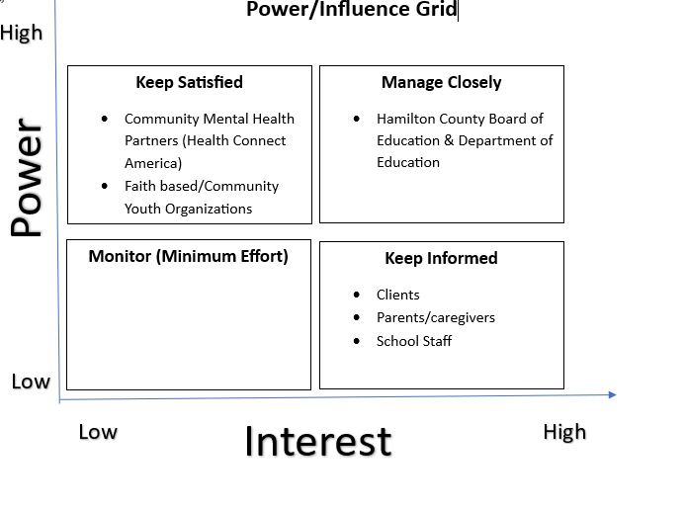

Appendix C
Logic Model

Appendix D-Survey/Interview guide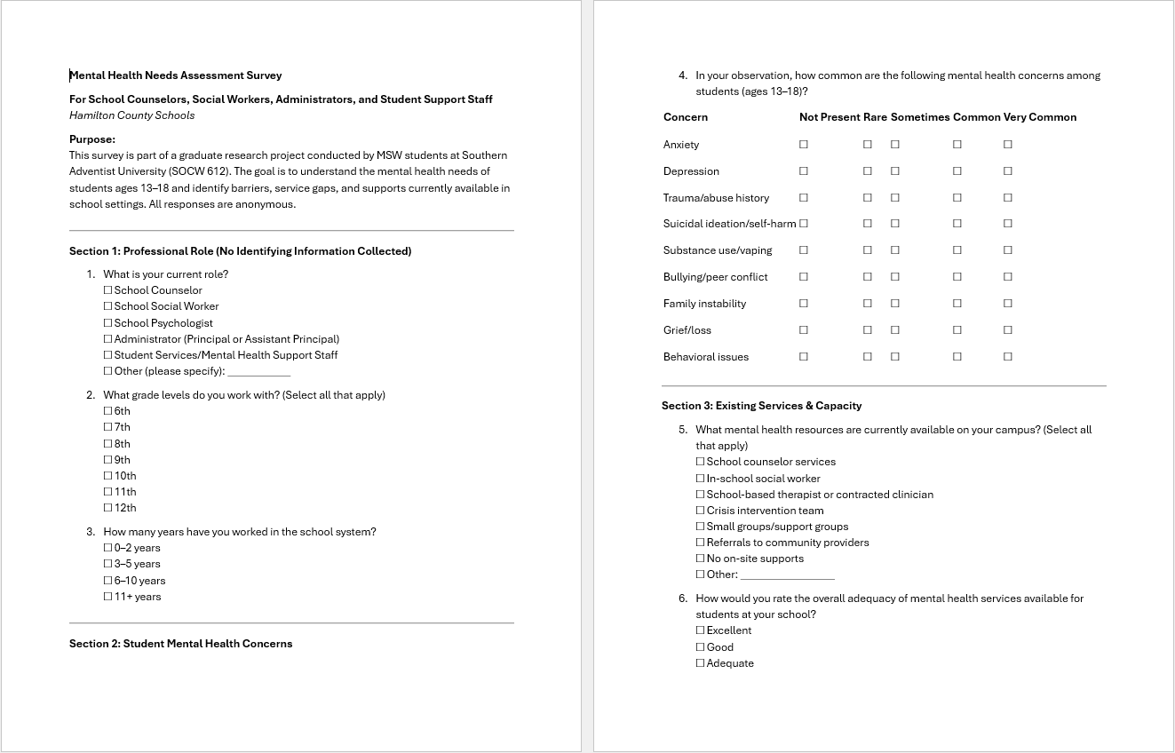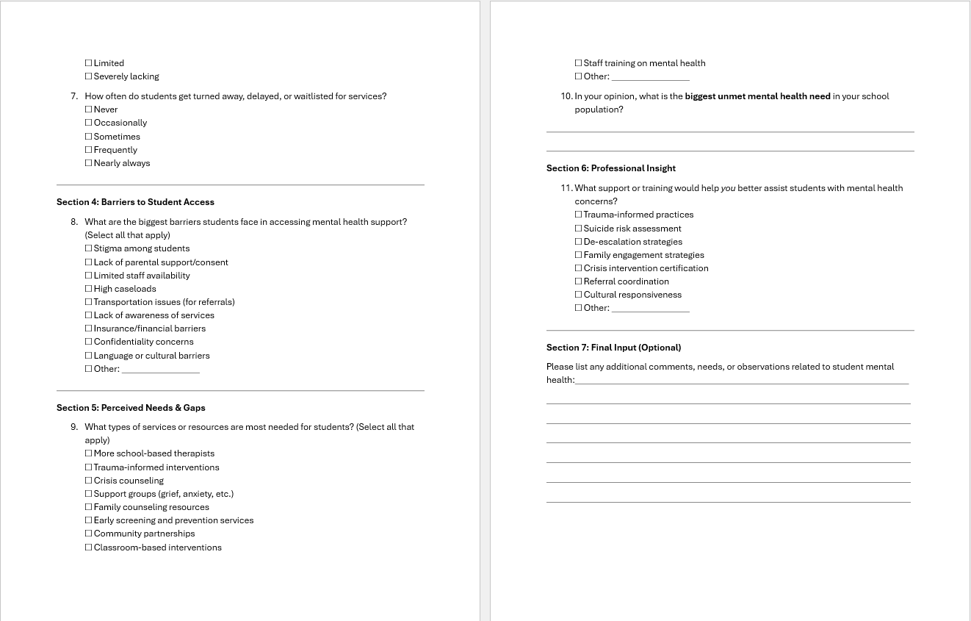
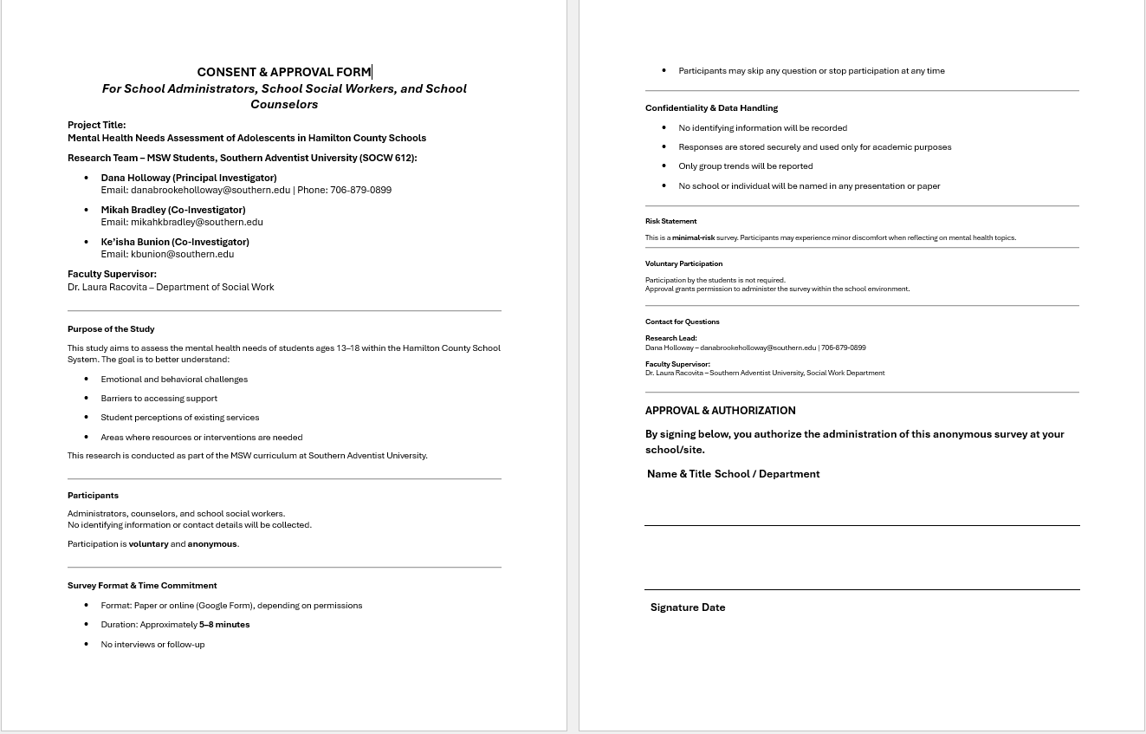
Appendix E- CITI Training Certificates