H.R. 2599 STANDUP Act of 2019

(The Suicide & Threat Assessment Nationally Dedicated to Universal Prevention)

Angela Anderson, Cornelia Campbell, Dewanna Posely

Southern Adventist University

Table of Content

Abstract………………………………………………………………. 3
Topic of Focus………………………………………………………...4
Theoretical Framework………………………………………………. 6
Researching the Issue………………………………………………… 7
Branding and Mapping Support……………………………………… 14
Potential Coalition Planning…………………………………………. 17
Media Campaign…………………………………………………….. 19
Advocacy Plan………………………………………………………. 22
Conclusion…………………………………………………………… 28
References…………………………………………………………… 30
Appendices………………………………………………………….. 35

Abstract
Suicide is a major issue in today’s society, with not only adults, but a growing rate of youths. Suicide is currently the 2nd leading cause of death amongst youths ages 10-24. Youths should be able to live a healthy childhood free from thoughts of suicide. The H.R. 2599 Suicide & Threat Assessment Nationally Dedicated to Universal Prevention Act of 2019 (STANDUP Act) seeks to establish suicide awareness and prevention policy in schools, as well as a prevention training policy aimed at developing in-school threat assessment teams. The STAND UP Act is currently a bill in Congress, and if passed, could be very beneficial with having a treatment team onsite at schools. They would be able to identify symptoms of suicide occurring with students, and providing them with the resources needed before it becomes a major issue. There are a few states, which have already implemented suicide assessment within schools. However the STANDUP Act seeks to implement this policy universally amongst all public funded educational institutions serving students in Grades 6 through 12.
The policies to be implemented by the STANDUP Act of 2019 in the school system, has been proven effective through evidence-based research in reducing suicide, bullying and aggression. These are major issues affecting youths in schools, and there have been increased reports of students taking their life because of being bullied. Spreading awareness of the importance of this bill could result in actions being taken and coalitions being formed to persuade state representatives to vote for it. The STANDUP Act would benefit students, school personnel, parents, families, society in general, and a potential for positive results in suicide rate reduction in the school system.

Topic of Focus
The Suicide & Threat Assessment Nationally Dedicated to Universal Prevention, or the STANDUP Act of 2019 (H.R. 2599), seeks to address issues surrounding the increasing prevalence of youth suicide, as well as widespread violence and mass school shootings in the U.S. The STANDUP Act would amend the Public Health Service Act requiring State-funded educational institutions under section 520A of the Act to establish suicide awareness and prevention policy in schools, as well as prevention training policy aimed at developing in-school threat assessment teams. If passed, the Act will serve students from grades six (6) through twelve (12). The STANDUP ACT advocates for youth but also impacts teachers, administrators, and other school staff, who will be liable to provide a safe and positive learning environment for students. The STANDUP Act could also have unintended consequences, as with any new legislation. At times, when increased attention is given to a specific topic or behavior, the opposite effect occurs and the behavior increases. Widened exposure may give the topic the wrong kind of attention. However, there is little evidence that discussion about youth suicide leads to increased suicide rates. Someone is already either thinking of suicide or not, so it is more likely that increased publicity will encourage those who are struggling to open up.
Supporters and Opposes of Policy
Congressmen from multiple states support this federal bill. It was originally introduced by congressman Scott Peters (D-CA-52) and Gus Bilirakis (R-FL-12) to the House Committee on Energy and Commerce on May 08, 2019. Co-sponsors include Theodore Deutch (D-FL-22), Brian Fitzpatrick (R-PA-1), Ann Fitzpatrick (D-AZ-2), Mike Quigley D-IL-5), Sean Maloney (D-NY-18), Debbie Wasserman Schultz (D-FL-23), Judy Chu (D-CA-27), Paul Tonko (D-NY-20), Jose Serrano (D-NY-15), Kathleen Rice (D-NY-4), and Drew Ferguson (R-GA-3). Along with these representatives; the National Association of Social Workers (NASW) signed on to a Sandy Hook Promise letter to declare their support for the passing of the STANDUP Act (H.R. 2599, 2019). Sandy Hook Promise is a national non-profit social services agency founded by members who lost a relative in the Sandy Hook Elementary Mass School Shooting. There are no current statistics, newspaper articles etc. revealing any opposing parties to this bill. However, potential opposition could be from congress representatives who have not cosponsored the bill, and government officials who might believe funding this policy on a universal basis could be costly for the government.
Context of Policy
The H.R. 2599 STANDUP Act of 2019 is currently a bill, which has been introduced into the House of Representatives for passing. The STANDUP Act, once enacted, would address issues surrounding the increase in suicide among youth in schools. It seeks to establish and implement school-based student suicide awareness and prevention policy, suicide prevention training, and school threat assessment team policy, within government funded educational institution. Our group will be advocating for the passing of this bill. The passing of this bill would implement policies in the school system that has been proven effective through evidence-based research in reducing suicide, bullying and aggression.
Importance of Policy
The STANDUP Act addresses the growing youth suicide crisis at a time when suicide is the second leading cause of death among youth 10 to 24 years of age in the United States (Mindwise Innovations, 2016). Suicide rates have tripled among this population since 1960, with 1,700 completed suicides taking place yearly (Crouse, 2014). This is particularly alarming since suicide is a preventable means of death, and because 4 out of 5 teenagers show signs of suicidal intent before making an attempt—signs which apparently go unheeded (The Jason Foundation, 2019).
There are a number of cultural, developmental, and individual risk factors that may contribute to suicidal behaviors among youth, and the STANDUP Act seeks to either prevent these behaviors or stop them in their tracks by implementing suicide awareness training and creating threat-based assessment teams in schools (Smischney, Chrisler, & Villarruel; 116th Congress, 2019). Currently, there are no youth suicide prevention policies that implement evidence-based interventions in schools. There are policies that increase the funds delegated to the increasing youth suicide rate, and suicide prevention training is now required as part of teachers’ basic training, but these policies do not directly implement interventions in schools like the STANDUP Act does (116th Congress, 2019; Mindwise Innovations, 2016).
Theoretical Framework
For this project the most appropriate theoretical approach would be the Huttman’s Policy Analysis Model. It is a very comprehensive approach, that inquires about what the unmet needs are, the policy’s goals and outcomes, possible implementation strategies, the scientific basis for the policy, the values embodied in it, the power bases supporting the policy, and the costs and benefits associated with implementing it. This approach will allow the group to explore all the possible benefits of the policy being passed and enable us to determine and report the extent to which it is needed. Many beneficial outcomes for implementing the policy can be identified through this policy analysis and then presented to the general public, as well as to electoral officials. It will also help determine possible supporters for the STANDUP Act and inform campaign members how to respond to any opposing arguments. The need for the policy can be demonstrated by providing statistics and other supportive research information highlighting the extent of the problem, illustrating how important it is for a policy to be put in place that effectively addresses the issue. The Huttman’s Policy Analysis Model giving us a step-by-step guide so advocacy efforts would be effectively executed.
Researching of the Issue
Nature of the policy
Suicide can be defined as at the intentional act of causing one’s death. Interestingly, it is currently the10th leading cause of death in the United States of America (USA), with 46,000 deaths reported in 2016, which can be calculated as one (1) death every twelve (12) minutes (CDC, 2018). According to the National Institute of Mental Health (NIMH) in data collected over a 16 year period-from 2001 to 2017 the suicide rate has increased by 31%- from 10.7 to 14.0 per 100,000. In the USA, suicide is the second leading cause of death for people ages 10 to 24, the fourth leading cause for those 35-54, and the eighth leading cause of death for those 55-64. The national fatal injury cost of suicide is in excess of $50.8 billion (NIMH, 2019).
Statistics from Youth Risk Behaviors Survey of 2017 showed that 17.2 percent of youths in grades 9 -12 reported having at least one suicide attempt in the past 12 months, with 2.4 percent resulting in treatment by a doctor or nurse (CDC, 2018). Within the twelve months before the survey, 13.6% of students nationwide made a suicide plan and 7.4 percent attempted suicide (CDC, 2018). There were also data showing that in 2017, 517 youths between the ages of 10 – 14 died of suicide, and within the age group of 15-24, 6,254 individuals died from suicide (NIMH, 2019). Female students were reported to have more attempts than male students (9.1% to 5.1%). African-American students rate of suicide attempt was 9.8 percent, as oppose to Whites with 6.1 percent (CDC, 2018).
It has been reported that twenty-seven (27) states have mandated suicide prevention training for school personnel; fifteen (15) states encourages training and twelve (12) states have so far required school suicide prevention, intervention and suicide prevention programming state wide (AFSP, 2016). The states of Delaware and Iowa are currently utilizing an evidence based approach within their school system (ASFP, 2019). There are several states that are taking action towards youth suicide crisis, but 100 percent participation by all states is needed. These youths need all the support they can get to minimize this suicide trend. They are the future leaders of the country and need to be in a healthy mental state.
In an attempt to bring awareness to the national public health issues of (a) gun violence in schools and (b) increased suicide rates-the H.R. 2599 Stand-up act of 2019 was drafted and introduced to the House of Representatives on May 8, 2019. The objective of the Stand-up Act is to establish and implement school based student suicide awareness and prevention training policy, and school threat assessment team policy, amongst other purposes. These policies would be guided by scientific evidence in making decisions about what programs would be beneficial for the youths. The Act will provide evidenced-based training to students in 6th to 12th grade regarding suicide education and awareness, being knowledgeable of warning signs for self-harm or suicidal ideation, suicide prevention and awareness resources, and retraining for students yearly (H.R. 2599, 2019).
Several teens, who attempt suicide, gave previous warning signs, but at times go unnoticed or adequate help wasn’t available at the early onset. The implementation of the Stand-up Act policies in schools would bring awareness to the warning signs of students who possibly pose a threat of harming themselves, leading to proactive steps being taken to assist those individuals. The passing of this bill would be an asset to academic institutions, educators, parents and the greater society.
Context Factor
Suicide can be traced all the way back to Ancient Rome where convicted criminals and also slaves, would take their own lives as opposed to facing harsh living conditions, or killed inhumanely by the governing body. Suicide was illegal in Rome, with an exception for soldiers who committed suicide as opposed to being killed by their enemies. They were noted as having an honorary death (Death in ancient Greece and Rome, 2013). Suicide continued to rise, even with the enforcement of laws against it in some countries.
The World Health Organization (2019) states on their website that every year approximately 800, 000 individuals around the world die from suicide, calculated as one person every 40 seconds. It further goes on to state that effective evidenced based interventions could be implemented at the population and individual level to prevent suicide and suicide attempts (W.H.O, 2019). The STANDUP Act bill also supports the W.H.O findings that evidenced based interventions can be effective in reducing suicide in schools and the population.
The United States of America opened their first suicide prevention center in Los Angeles, California 1958, with funding from the U.S Public Health Service (National Strategy for Suicide Prevention, 2012). Then, in 1966 the Center for Studies of Suicide Prevention was established by the National Institute of Mental Health (NIMH), which was followed by the creation of nonprofit organizations dedicated to the cause (National Strategy for Suicide Prevention, 2012). In 1983, the Centers for Disease Control and Prevention (CDC) developed a violence prevention program that brought public attention to the disturbing increase in the youth suicide rate. Then in 1985, the Secretary’s Task Force on Youth Suicide was established to review the problem and make recommendations.
It was not until the 1990s that the United Sates formally recognized how big of a problem suicide was in the country (National Strategy for Suicide Prevention, 2012). This awareness was accomplished through efforts of a citizen-initiated campaign from groups of suicide loss survivors, who began drawing attention to the need to address suicide prevention in the nation. These efforts resulted in two congressional resolutions being made (National Strategy for Suicide Prevention, 2012). The first recognized suicide as a national problem, and the second dubbed suicide prevention as a national priority. A public-private partnership developed thereafter, which sponsored a conference in 1998 on suicide prevention in Reno, Nevada, where 81 recommendations were made for the prevention of suicide in our country (National Strategy for Suicide Prevention, 2012). The conference is viewed as the founding event for the modern suicide prevention movement. In 2001, a Federal Steering Group was created to develop a national strategy for suicide prevention, published by the World Health Organization and the United Nations (National Strategy for Suicide Prevention, 2012).
All of these movements resulted in government agencies at all levels starting the implementation of programs to address suicide prevention in—schools, nonprofit organizations, and businesses. Also in 2001, the National Suicide Prevention Lifeline created a national network of certified local crisis centers (National Strategy for Suicide Prevention, 2012). Prevention strategies were increasingly implemented at the state and local levels. Still, little was being done about the increasing youth suicide rate. Due to increased public recognition of increased youth suicide rates, reducing the youth suicide rate become a major focus of the U.S suicide prevention agenda, and youth suicide prevention programming has increased dramatically in the past decade. The rise of suicides among youth has become deeply upsetting, creating a general concern about the issue, in tandem with increased rates of school shootings and other kinds of violence. It has become critical for the country to provide support to help schools develop effective suicide awareness and prevention programs, and to this point no federal policy has implemented evidence-based interventions in schools aimed at decreasing the youth suicide rate.
The STANDUP Act will address this problem if enacted by requiring states, public schools, and tribes to implement evidence-based policies to prevent youth suicides in order to receive certain types of grants related to the promotion of mental health awareness and improving connections to services for school-aged youth. It would implement suicide awareness training in schools, as well as in-school threat-based assessment teams intended to identify youth at risk.
The bipartisan bill will also require the Substance Abuse and Mental Health Services Administration to provide technical assistance in implementing these policies. Other federal suicide legislation has taken place this year as well, including an amendment to H.R. 2740 (the Appropriations Act of 2020), which increases funding for the substance abuse and mental health services administration by $6.5 million in order to support youth suicide prevention strategies. Also, the National Suicide Hotline Legislation Act of 2019 has been referred to the House Committee on Energy and Commerce, and it would designate 9-8-8 as the universal telephone number for the purpose of national suicide prevention (H.R.4194, 2019). These policies can work together with the STANDUP Act to address the youth suicide crisis, but only the STANDUP Act implements evidence-based interventions in schools for the prevention of youth suicide.
Policy Impact
This bill is not yet enacted into law but there are organizations and present policies that strive to prevent suicide and provide threat assessment in our country. According to Joe and Bryant (2007) as the place where adolescents spend the majority of their waking hours outside of home, school is an important venue for screening adolescents for suicidal behaviors and providing preventive education and risk management services. Indeed, it has been shown that school-based programming is the most common approach when it comes to addressing youth suicide. Aseltine and DeMartino (2004) noted that many preventive suicide screening programs have not been scientifically evaluated and those that have yielded mixed results. This review also revealed that the primary goal of many screening programs is often not to have a direct impact on suicidal behavior but rather to increase help-seeking behavior (Joe and Bryant, 2007).
Counselor CARE (C-CARE) and Project CAST (Coping and Support Training) are two school-based suicide prevention programs seeking to enhance youth’s sense of personal control through skills training (Eggert et al., 1995). These two programs were tested on 150 youths in grades 9-12. Results of the test showed that both programs were effective in enhancing self-esteem, reducing anxiety and anger control problems in females, effectively reduced depression and hopelessness, and decrease in drug use. Growth curve showed a decline in suicidal behavior and ideation in both programs (Eggert et al., 1995).
Social workers, if given the appropriate training, time, and financial resources, could be instrumental in the implementation of screening and preventive educational programs. Future research is needed to discern social workers' ability to develop effective screening programs and to address teenagers' experiences of service barriers and what happens after they are referred for services (Joe and Bryant, 2007).
Future Direction of Policy
The proposed policy is the Stand Up Act of 2019 which is an amendment to the Public Health Service Act to require State educational agencies and tribal educational agencies receiving funds under section 520A (of Title V Public Health Service) to establish and implement a school-based suicide awareness and prevention policies. This proposed policy has not gotten far in the House so there is not much direct research. Some of the gaps will occur from the state level aligning to the federal level. So the first future direction of this proposed policy is to make sure it becomes a policy. This is where we must advocate in ensuring that our representatives understand the importance of this bill. The need for the Public Health Service Act did not include a universal policy for school-based suicide awareness and prevention training policy and school threat assessment team policy, so this resulted in it being amended to introduce the STANDUP Act.
The CDC recognizes that suicide has become a big public health problem. The direction they are taking is organized around four general areas of public health research and practice: measuring impact, creating and evaluating new approaches to prevention, applying and adapting what we know works, and building community capacity. Including school threat to this policy also addresses a greater need for students in our schools (CDC, 2019).
Schools are a key setting for suicide prevention. Teachers, mental health providers, and parents all play a vital part with the implementation of the proposed policy (Suicide Prevention Resource Center, 2019). Most states have strategic direction for the prevention of suicidal behavior. They recognize the need to have a plan in place. Some of the state legislation even includes suicide prevention amendments as well as school goals.
Washington State House Bill 2315 passed legislature in 2014 regular session for general suicide prevention amendment. Other relevant Washington State legislation include ESHB 1336(2013), RCW 28A,410.226; ESHB 1336(2013), RCW 28A,310.500 to name a few (Washington State Suicide Prevention Plan, 2019). California, Virginia, and many other states have strategic plans as well as legislation in place to address suicide issues in schools. The bill will include making a universal policy where state money is available, so school policies can be universally aligned from the federal level.
This proposed bill will begin to provide a universal model for all states. Student’s mental health is on a downhill slide and the schools are a perfect place for this proposed policy. Awareness is big. Implementation is just as big. This bill just started going through the process so the passage of this bill is still a ways off. The lingering question will be the implementation process after the proposed policy is passed in the House.
Branding and Mapping Support
To bring awareness to the issue surrounding suicide, the bran “Let No Youth End Life” will be used. The organizing principle behind the brand “Let No Youth End Life” moves away from blaming individuals for the youth suicide problem and moves towards a community-based solution to the problem. Saying “Let” (“No Youth End Life”) implies that together it is our responsibility as a society to do all we can to prevent youth suicide. It calls people to action and emphasizes that not acting at all is contributing to the problem. It doesn’t blame youth, parents, or the school system for increasing youth suicide rates, but points out that all of us play a role in the crisis, even if that role is inaction—and that inaction contributes to the problem. Thus, we must do something to effectively tackle this social problem together.
The value Americans place on youth and life itself is also part of the framework. This value serves as the anchor of the framework. Saying (“Let No”) “Youth End Life” reframes the term “Youth Suicide” to point out that it is about death taking place far too soon, in a culture that highly prizes the joy of youth and the hope of a long life. There is also a paradox in the framework, because youth refers to new life, and in youth suicide we see life being brought to an end very early even though it is preventable and needless. Youth itself and the end of life are at different ends of a continuum, and we should do all we can to prevent the loss of life—and certainly young life.
Our brand “Let No Youth End Life” recognizes that solutions require collective participation from the mass public, rather than singling out individuals to make changes when the problem is so much larger than they are. The framework is thematic rather than episodic—it focuses on political and environmental factors that contribute to the youth suicide problem rather than bringing up a psychological debate or placing blame on certain people or organizations (The Framework Institute, 2019). Also, the tone of the framework is reasonable rather than argumentative, so that it calls for logical action rather than criticism or negativity.
Supportive Arguments
There are several supportive arguments that could be used to sway potential supporters of
the bill, which are undecided, such as:
● With suicide continuing to be the second leading cause of death in those 15-24 years old, it is important for at risk youth to have access to mental health treatment. Reyes-Portillo, Chin, Toso-Salman, Blake Turner, Vawdrey, & Mufson 2018 recognize through research that majority of suicide events occur within 4 weeks of an intake for treatment.
● Services and Support should emphasize prevention, early identification and intervention in order to maximize positive outcomes (Huang, Stroul, Friedman, Mrazek, Friesen, Pires, & Mayberg, 2005).
● Healthy relationships are important for youth to have with their teachers, peers, administrators, and other school staff–essential relationships in which youth can trust adults and friends and confide in them.
● According to Huang, Stroul, Friedman, Mrazek, Friesen, Pires, & Mayberg, 2005, Schools are where children spend each weekday. Schools should be supported to meet the social-emotional needs of children to ensure that they are healthy and ready to learn.
● Suicide rates cost the country billions of dollars. The incorporation of an evidence-based program within the school system will aid in reducing suicide rates within the country, saving billions of dollars that could be used to fund the program. The World Health Organization (2019) state that effective evidenced based interventions could be implemented at the population and individual level; this could potentially prevent suicide and suicide attempts, which supports the STANDUP Act policies.
Possible Oppositions to Policy
Potential oppositions to the policy could be from Republicans; only three (3) Republicans are currently co-sponsoring the bill. Oppositions could also come from mental health professionals, mental health institutions, and state government.
Notes on Oppositions:
- There have been inquiries to ascertain possible opposition to the bill; but to date, there has been no known opposition.
- The bill was introduced by a Democratic representative, which could be a reason for Republicans being reluctant to co-sponsor the bill. However, advocacy efforts could possibly sway more Republicans to be proponents of the bill.
- Mental health institutions and professionals might move away from opposing the bill to endorsing it, based on the educational qualifications of the individuals who will be trained to work in the schools and implement the interventions which are part of the STANDUP Act. Also, they may question whether or not such policies would be effective in reducing suicide rates in schools, and may fear the possibility of losing potential clients if the program is successful.
- State governments might oppose the bill, due to the cost of funding such a large program.
Potential Coalition Planning
There has been much publicity as well as general hype about addressing the increasing youth suicide rate, so forming a coalition shouldn’t pose any issues. The main coalition would be with the Tennessee school system, where the policy would be implemented. The school system could play an important role by having teachers and guidance counselors as speakers at campaigns, discussing the issues surrounding suicide in schools and how it affects the school population on a whole. The kind of coalition that would advance our campaign would also include agencies that deal with the prevention of fatal and nonfatal suicidal behaviors in youth. Three of these in our state are the Tennessee Suicide Prevention Network’s Youth Initiative (2019), the Prevention Coalition for Success, and the Suicide Prevention Resource Center of Tennessee (Suicide Prevention Resource Center, 2019). The Suicide Prevention Resource Center has information on various programs we could utilize in our campaign. Resources from the center could be used to craft individuals and other organizations to join the coalition.
It would also be beneficial to invite the American Foundation for Suicide Prevention to join the coalition; because they have created a model school policy on suicide prevention that would give educators a roadmap showing how new interventions can be implemented in the school system (A Model School Policy on suicide prevention, 2019). They could present their model to communities as part of our advocacy efforts. Concerning the “odd bedfellows” who could join our coalition, out of 27 representatives co-sponsoring the STANDUP Act, only 3 are Republicans (H.R. 2599, 2019). Therefore, we need to enlist as many Republicans as we can for our coalition so that they can influence their own party. Republicans tend to be more cautious about distributing resources since they are needed for so many projects, and because implementing new programs can be so costly. Republicans may want proof that the would-be programs will be effective and that the practical implementation of the policy will be overseen. Republicans will be happy to know that the interventions in the STANDUP Act are evidence-based, and that as part of the STANDUP Act the Substance Abuse and Mental Health Services Administration (SAMHSA) will be overseeing the introduction of the Act’s interventions into the school system. Therefore we also want SAMHSA to join our coalition.
In addition, certain regions in the country show less enthusiasm than others for the passing of the STANDUP Act, as far as where co-sponsors for the bill are from, so it would be beneficial to include members in the coalition from those areas who can talk to their elected officials. Other organizations focused on youth suicide prevention in those areas could also be enlisted, and in that way the advocacy activities would go beyond state borders and broaden the campaign efforts significantly. Co-sponsors for the STANDUP Act are predominantly from California, New York, Georgia, Florida, and Pennsylvania, with only a few other states having a co-sponsor for the bill (H.R. 2599, 2019). The Northeast, the Southeast, and the West are largely represented, but there is little support from the Midwest or Southwest regions. It would be important to enlist coalition members from these areas to expand the campaign borders, adding both individuals and organizations that could potentially enhance advocacy efforts.
Media Campaign
The main aim of the campaign is to educate and sway as many individuals as possible to support the STANDUP Act bill, and implore them to contact their elected state representatives about voting to get this bill passed.
The general public: There are many families who have lost loved ones due to suicide. During our campaign we could appeal to these families, as well as the general public to speak with their state representatives about the importance of this bill becoming law.
Republican representative: Out of 27 representatives co-sponsoring the bill, only three are republicans. The aim would be to sway more Republicans to vote for the passing of the bill. Also, encourage current republicans co-sponsoring the bill, to influence their fellow representatives, in voting for the passing of this bill.
The school system: School officials interact with suicide victims on a regular basis, and having them on board discussing the need for this policy would really help the campaign. Representatives from different schools, such as social workers, and counselors could be asked to speak at different campaigns, about how suicide has affected their school population.
Co-sponsors for the STANDUP Act are predominantly from California, New York, Georgia, Florida, and Pennsylvania, with only a few other states having a co-sponsor for the bill. The Northeast, the Southeast, and the West are largely represented, but there is little support from the Midwest or Southwest regions. The hope is that individuals and groups from Midwest and Southwest regions of the country would join the coalition which would be beneficial in expanding our campaign borders, adding both individuals and organizations that would enhance our advocacy efforts.
Media Avenue
The media outlets that the group will be utilizing to promote the STANDUP Act bill are as follows: There will be Television commercials on ABC, NBC, CBS, and FOX channels; Social media outlet accounts of Facebook, twitter, and Instagram; Along with various events like Hope Run & Hope Clubs, including but not limited to Suicide Awareness month.
To content of the media messages seeks to gain public and governmental support to improve youth suicide prevention. On each social media platform a contact page will be included.
Facebook page will include topics and resources on bullying, online safety, cyber bullying, student mental health, and youth suicide awareness and prevention initiatives. Helpline contact information will also be included. Description and updates on the proposed policy status will be linked to the site. Please follow our Facebook page at www.facebook.com/letnoyouthendlife
Twitter page will have tweets such as: Please tweet #LetNoYouthEndLife #Standupact2019 #HOPES2019 for policy updates, resources and announcements.
Television Commercial – Discuss 5 teens, with different backgrounds experiencing suicidal issues. With music playing in the background, each teen will take turns giving common signs that a teen is considering suicide. Next, they will provide suggested ways to help.
TEENS:
Common Signs: “Withdrawal form family or friends, drastic personality change, giving away prized possessions, doing worse in school, noticeable changes in eating or sleeping habits, unexplained or usually severe, violent, or rebellious behavior.”
Communication: “Ask direct questions. Listen to their answers. Do a safety check. Don’t keep this a secret. Make sure they seek professional help.”
Announcer: (On the screen, is CALL 1-800 – 273 – TALK National Suicide Prevention Lifeline (Suicide Prevention Lifeline.org)
“Say something! Do Something! Help us reduce youth suicide through awareness and prevention by supporting the enactment of the STAND-UP ACT 2019 and let our youth live.
EVENT: HOPES RUN – Get Hooked on Prevention and Ending Youth Suicide!
Plans for this fund-raising event will take place during Suicide Prevention Month in major cities. The first week-end of each month, we will highlight suicide awareness/prevention through informational tables at educational institutions and government buildings.
HOPES CLUB – Get Hooked on Prevention and Ending Youth Suicide will be launched to advocate at colleges and universities in different states to emphasize that NO YOUTH END LIFE. This group will also help to advocate the STAND-UP ACT of 2019 at the government level.
Proposed Campaign Implementation
Our campaign will begin by setting up each social media site. Our group will dedicate a full day on October 27, 2019 in order to set up Facebook, Instagram, and twitter. We will begin posting pictures, stories, filers, events, etc. to each account to showcase the importance of the bill. We will then head to the News stations to promote the STANDUP Act bill, Fox News will feature us on their station scheduled to air on October 28, 2019. Next, a T.V. commercial will be filmed on October 30, 2019 and submitted to the appropriate source by November 2, 2019. This T.V. ad will air on ABC, NBC, FOX, CBS channels, pending approval on November 4, 2019. Next, we will set up an informational table at various events to promote and provide details on how the STANDUP Act bill will benefit their local schools and communities. Majority of the events we will attend will be located in the four regions of Tennessee: Region 1-Knoxville; Region 2-Chattanooga; Region 3- Nashville; and Region 4 – Jackson. We will start in Tennessee and then expand to other major cities to gain support to advocate to both the United States House of Representatives and United States Senate. Last, but not least, we will tour major counties in different states, setting up informational table the first week-end of each month beginning in September 2020 during the Suicide awareness month.
Advocacy Plan
The goal of the advocacy plan is to educate state representatives about the importance of the STANDUP Act and the need for them to vote to get it passed. The enforcement of the STANDUP Act policies within the school system has the potential to reduce the amount of suicide ideation, and attempted suicide of students. This would be a success for the country/community as a whole.
The Focus of the advocacy plan is mainly towards the U.S congress, the community, and schools. Legislators are crucial proponents to this bill being enacted. They are the ones making the crucial decision whether or not to vote for the bill’s passing. Community members are also influential in contacting the state representatives about their support of the bill. Families who have lost loved ones to suicide, would be utilized during outreach efforts to tell their story, and how it has affected them. School personnel such as teachers and guidance counselors would be asked to speak at campaign events about the issue of suicide and its effect on the school population.
The target population for the advocacy plan includes the students who are the most important beneficiary of the plan’s implementation. Next are the teachers and other staff members who interact with the students on a daily basis. Parents and family members are affected by their child’s issues on a daily basis. There are also families who have lost loved ones to suicide. These individuals would be influential in advocating and persuading their state representatives about the importance of voting for the STANDUP Act bill to be passed, because of experience with these youths.
The US Department of Health and Human Services Substance Abuse and Mental Health Services, states that one strategy for effective advocacy will include research informed communication to change knowledge, attitudes, and behaviors concerning preventing suicide (SAMHSA, 2017). This will be done by reaching out to the community to help rally support of legislators through different forms of communication.
The National Institutes of Health Pathways to Prevention (year) Workshop concerning “Advancing Research to Prevent Youth Suicide” worked with many other groups in a multidisciplinary fashion to report about this ever-growing problem. This report will enhance the advocacy strategy as we look at the impact that identifying persons at risks of suicide has on society (Institute of Medicine, 1970).
Evaluation of long-term public education campaigns and media training, reduction of access to guns, and participation of health care providers to involve families will be selling points to lawmakers as we try to encourage them to support finding ways to reduce youth suicide (Institute of Medicine, 1970).
Managing risk factors as a strategy helps to assess risks that may be encountered will strengthen your advocacy plan. Cheryl King with the University of Michigan National Network of Depression Centers suggests effective approaches to address this issue of suicide. Targeting the suicide risk is considered paramount in having an impact on the suicide risk factors. Is important to analyze She suggests creating a “safety plan” to help with this population. She also realizes that financial resources can be a problem. That’s why it’s important to advocate Stand-Up Act of 2019 to make sure finances becomes less of a problem (Strategies for assessing youth suicide, 2019).
Suicide prevention is an important topic and it is important to get as many people on board so our message can be heard. Our stakeholders include students, teachers and other family members. We will enlist their help, as well as help from the community to help raise public awareness of our message of support for the Stand Alone 2019 proposed bill with legislators through specific online and offline activities. Legislators are needed to push the proposed Stand UP Act 2019 bill forward. First, the message will clearly explain our cause. A database system will be used to keep the database of donors, volunteers and other supporters current. Our supporters will spread the word by making a shopping mall display and/or using social media among other activities. To reach our legislators, group members will be asked to organize a day at the Capitol for young people to tell legislators their testimony about their friends who have committed suicide or those who struggle with suicidal ideation. A display of suicide prevention facts created and placed in the legislation chambers will create more awareness about the problem (Sample Advocacy Strategies, 2017).5 Supporters will be enlisted from various major states to make sure this federal proposed bill get the attention of major legislators.
The positive ramifications of involving the population in our advocacy activities include bringing together a diverse range of people because diversity can strengthen our campaign. Support and encouragement from each other can also be a benefit of involving the population. We can use the different skills, experiences, and information to get a range of ideas and support efforts. The students will have an opportunity to develop leadership skills while working with others in the group.
Some of the drawbacks include the time needed to get everyone doing their assigned roles. There may be difficulty in monitoring/evaluating all of the groups which may affect the success of the coalition. Shopping Malls/Legislative Chambers may not all accept this type of display. Talking about the topic of suicide is beneficial, but care should be taken when involving students during the day at the Capitol as they give their testimony. Students may not be emotionally ready to handle this situation. Mental Health Counselors should be present to help the students process their thoughts during this day. In spite of the drawbacks that may occur, the idea of everyone working together to reach the end goal of getting support for Stand Up Act 2019 will help with reducing suicide among our youth.
There is currently no known opposition to the bill; however implementation of the bill could potentially pose an issue with several individuals. A large portion of the bill’s supporters currently in congress are democrats, through whom it was created. Republicans may be reluctant to participate in the bill’s passing, due to having no input in its formulation. Mental health institutions/professionals might oppose the bill, due to the possibility of losing new clients or current clients to the programs that would be implemented in the schools. Questions could arise about the educational qualification of individuals to be trained to work in the schools in promoting suicide awareness and working with school personnel to address the issues of suicide. In addressing this concern, the group would reassure the opposition that all individuals would receive training through a government entity, and undergo rigorous screening to ensure they meet the qualification. The state and federal government might oppose the bill, due to promotion of a universal program across states and the cost to fund it.
If any of the above-mentioned oppositions occur, it would be important to distribute fact sheets and policy briefs about the extent of the problem to these individuals. Another step that could be taken is to invite opposers of the bill to a question and answer sessions, where they could voice their concerns and receive answers to their questions. To address the issue of cost, they will be provided with facts about how an evidenced-based approach would result in a successful program in which suicide and gun violence would be reduced, saving the country billions of dollars, which could be used to continuously fund the program. They would be asked to invest in the policy for a year and then evaluate the result and make an informed decision.
Many of those opposing the bill could be viewed as potential consumers. Our main consumers would be the school officials that would be implementing the policies of the bill at their educational institutions. Conferences would be held to discuss the importance and evidenced based impact of the STANDUP Act within the school. School officials could be asked to talk with state representatives about how suicide is affecting the school population, and the need for them to take action. Parents could also be incorporated; especially those who have lost loved ones to suicide of have a child that has attempted suicide. Having this group of consumers on our side would potentially yield positive results in swaying representatives to vote for the bill. Topics to discuss includes how this bill benefits their children, how this bill will be implemented into each school, what training would look like for the students, and teachers. It is important to involve consumers and family members because they are a part of the process in assisting to get this bill passed. Consumers and family members are an important piece in passing this bill, as well as those elected to represent their perspective state.
The elected officials that would need to be approached about the bill includes; Rep Nancy Pelosi, Rep. Steny Hoyer, Rep. Kevin McCarthy, Rep. James Clyburn, Rep. Steve Scalise, Rep. Liz Cheney, Rep. Ben Lujan, Rep. Gary Palmer and Rep, Hakeem Jeffries from the U.S. Congress House of Representative, who are influential persons in congress, especially Nancy Pelosi. Other officials needed are the current sponsors and co-sponsors of this bill. The first contact would be in the form of an elevator pitch being written and mailed to each State Representative office, giving them an understanding on what and why we are advocating for this proposed bill to be passed. There would be a follow-up via email or phone, and if accepted, the group would then seek to schedule a professional meeting with all representatives who replied to the elevator pitch. The group would also ask school officials and parents from several different school and communities to attend the meeting in an effort to form a coalition to persuade the representatives to vote for the bill.
At the meeting, some of the main topics that would be important to discuss includes the increasing rates of youth suicide within the school and how much it is costing the country. Next is the importance of protecting our youth from violence in the school settings. Pointing out the number of school shootings occurring each year and how it has been affecting the school population, families and communities. A third point is facts on how the evidenced based approach of the bill would aid in creating positive mental health status within the youths, helping them to focus on their education, and go on to living a productive life contributing positively to the society.
The bill will be monitored through the website www.billtrack50.com and www.congress.gov. Members of the coalition will be assigned specific task to monitor the bill. One group will be assigned to check the status of the bill monthly, by contacting congressmen Scott Peters (D-CA-52) and Gus Bilirakis (R-FL-12) for updates on the status of the bill. Another group will be responsible for keeping in touch with other supporters of the bill, via social media such as Facebook and Instagram, giving them quarterly updates. Another group will also be responsible for keeping track of the newly proposed bill S.2492 - Suicide Training and Awareness Nationally Delivered for Universal Prevention Act of 2019 similar to that of H.R. 2599 by checking the website www.congress.gov.
Conclusion
The Let No Youth End Life Coalition is a group that was created to bring awareness to the continuous increase in youth suicide and the need for action to be taken within the schools to address this issue. The goal is to have the H.R. 2599 STAND-UP Act passed in congress, so that there will be trained personnel within the schools who are able to identify students who show symptoms of suicide intent. If enacted the students would also be taught coping skills that would aid in managing suicidal thoughts at an early stage. Evidence-based interventions would be the emphasis of the STAND-OP Act, which research has shown to be effective in decreasing suicide, gun violence and bullying within schools.
The bill is currently awaiting passage in congress, and thus the coalition is working towards persuading more congressmen to support this bill so it can get passed. Congress needs to realize that the health and safety of these youth should be top priority. No family is exempt from this happening to their child, so action should be taken by congress to pass this bill to better the lives, and mental health of these youths, who will be the future leaders of the country.

References
American Foundation for Prevention, (2019). State Laws: Suicide Prevention in Schools (K-12). Retrieved from http://afsp.org/wp-content/uploads/2019/06/AFSP_K-12-Schools-Issue-Brief_6-7-19.pdf
American Psychological Association.(2019). Children’s Mental Health; Why is children’s Mental Health Important. Retrieved from: https://www.apa.org/pi/families/children-mental-health
Aseltine, R. H., & DeMartino, R. (2004). An outcome evaluation of the SOS suicide prevention program. American Journal of Public Health, 94, 446-451.
A Model School Policy on Suicide Prevention. (2019, September 6). Retrieved from https://afsp.org/our-work/education/model-school-policy-suicide-prevention/
Bill Track 50. (n.d.). US H.R. 2599. Retrieved from https://www.billtrack50.com/billdetail/1122335
California Strategic Plan on Suicide Prevention. (n.d.) Retrieved from
http://archive.mhsoac.ca.gov/Meetings/docs/Meetings/2008/Feb/CODSPACRec1107.pdf
Center for Disease Control and Prevention. 2019. Preventing suicide. Retrieved from https://www.cdc.gov/violenceprevention/suicide/fastfact.html
Center for Disease Control and Prevention, (2019). Youth Risk Behavior Surveillance —
United States, 2017. Retrieved from https://www.cdc.gov/healthyyouth/data/yrbs/pdf/2017/ss6708.pdf
Clay, R. (2014).A public health approach to suicide. The federally funded Suicide Prevention Resource Center offers training, publications and more. Retrieved from: https://www.apa.org/monitor/2014/04/suicide.
Crouse, J.S. (2014, January 9). Sad Truths About Teen Suicide. Retrieved from https://www.americanthinker..com/articles/2014/01/sad_truths_about_teen_suicide.html
Death in ancient Greece and Rome. (2013). In A Companion to Ancient History. New York: Facts On File. Retrieved December 12, 2019, from online.infobase.com/Auth/Index?aid=97819&itemid=WE49&articleId=369163
Eggert, L. L., Thompson, E. A., Herting, J. R., & Nicholas, L. J. (1995). Reducing suicide potential among high-risk youth: Tests of a school-based prevention program. Suicide and life-threatening behavior, 25(2): 276-296. Retrieved from https://onlinelibrary.wiley.com/doi/abs/10.1111/j.1943-278X.1995.tb00926.x?sid=nlm%3Apubmed
H. R. 2599 The Standup Act: Retrieved from https://www.congress.gov/bill/116th-congress/house-bill/2599/text
H.R.4194 - National Suicide Hotline Designation Act of 2019: Retrieved from https://www.congress.gov/bill/116th-congress/house-bill/4194
Institute of Medicine (US) Committee on Pathophysiology and Prevention of Adolescent and Adult Suicide. (1970, January 1). Programs for Suicide Prevention. Retrieved from https://www.ncbi.nlm.nih.gov/books/NBK220931/
Joe, S., & Bryant, H. (2007). Evidence-based suicide prevention screening in schools. Children & Schools, 29(4), 219–227. Retrieved from http://search.ebscohost.com.ezproxy.southern.edu/login.aspx?direct=true&db=swh&AN=56699&site=ehost-live&scope=site
Institute of Medicine (US) Committee on Pathophysiology and Prevention of Adolescent and Adult Suicide. (1970, January 1). Programs for Suicide Prevention. Retrieved from https://www.ncbi.nlm.nih.gov/books/NBK220931/
Northern Virginia Suicide Prevention Plan Final Version ... (n.d.). Retrieved from https://www.fairfaxcounty.gov/community-services-board/sites/community-services-board/files/assets/documents/pdf/regional-plan.pdfarchive.mhsoac.ca.gov/Meetings/docs/Meetings/2008/Feb/CODSPACRecs1107.pdf
Prevention Coalition for Success. (n.d.). Retrieved from https://www.pc4s.org/
Reyes-Portillo, J. A., Chin, E. M., Toso-Salman, J., Blake Turner, J., Vawdrey, D., & Mufson, L. (2018). Using electronic health record alerts to increase safety planning with youth at-risk for suicide: A non-randomized trial. Child & Youth Care Forum, 47(3), 391–402. https://doi-org.ezproxy.southern.edu/10.1007/s10566-018-9435-4
Sample Advocacy Strategies. (2017, May 4). Retrieved from https://www.nacac.org/advocate/how-to-advocate/sample-advocacy-strategies/.
Smischney, T.A., Chrisler, A., & Villarruel, F.A. (2014, January). Risk Factors for Adolescent Suicide (Research Brief). Retrieved from https://reachfamilies.umn.edu/sites/default/files/rdoc/Adolescent%20Suicide.pdf
Strategies For Addressing Youth Suicide-And The Barriers to Effective Treatment. (n.d.). Retrieved from https://careforyourmind.org/strategies-for-addressing-youth-suicide-and-the-barriers-to-effective-treatment/.
Strategic Direction for the Prevention of Suicidal Behavior. (n.d.) Retrieved from https://www.cdc.gov/violenceprevention/pdf/suicide_strategic_direction-one-pager-a.pdf
Suicide data. (n.d.). World Health Organization. Retrieved from https://www.who.int/mental_health/prevention/suicide/suicideprevent/en/
Suicide Prevention Resource Center. (n.d.). Retrieved from

http://www.sprc.org/
Tennessee Suicide Prevention Network’s Youth Initiative. (n.d.). Retrieved from https://www.tspn.org/
The Framework Institute. (2009). Changing the Public Conversation on Social Problems: A Beginner’s Guide go Strategic Frame Analysis. Retrieved at https://www.sfa.frameworkinstitute.org
The Jason Foundation. (n.d.). Youth Suicide Statistics. Retrieved from http://prp.jasonfoundation.com/facts/youth-suicide-statistics/
The National Institute of Mental Health (NIMH). 2019. Suicide. Retrieved from https://www.nimh.nih.gov/health/statistics/suicide.shtml
U.S. Department of Health and Human Services Substance Abuse and Mental Health Services Administration. (2017). National Strategy for Suicide Prevention Implementation Assessment Report. Rockville, Maryland: SAMHSA. Retrieved from https://store.samhsa.gov/system/files/sma17-5051.pdf
Washington State Suicide Prevention Plan - doh.wa.gov. (n.d.). Retrieved from https://www.doh.wa.gov/Portals/1/Documents/Pubs/631-058-SuicidePrevPlan.pdf
116th Congress. (n.d.). All Information (Except Text) for H.Amdt. 299 to H.R. 2740. Retrieved from https://www.congress.gov/amendment/116th-congress/house-amendment/299
2012 National Strategy for Suicide Prevention: Goals and Objectives for Action: A report of the U.S. Surgeon General and of the National Action Alliance for Suicide Prevention. Washington (DC): U.S Department of Health & Human Services (US); 2012 Sep. Appendix C, Brief History of Suicide Prevention in the United States. Retrieved from: https://www.ncbi.nlm.nih.gov/books/NBK109918/

Appendix B

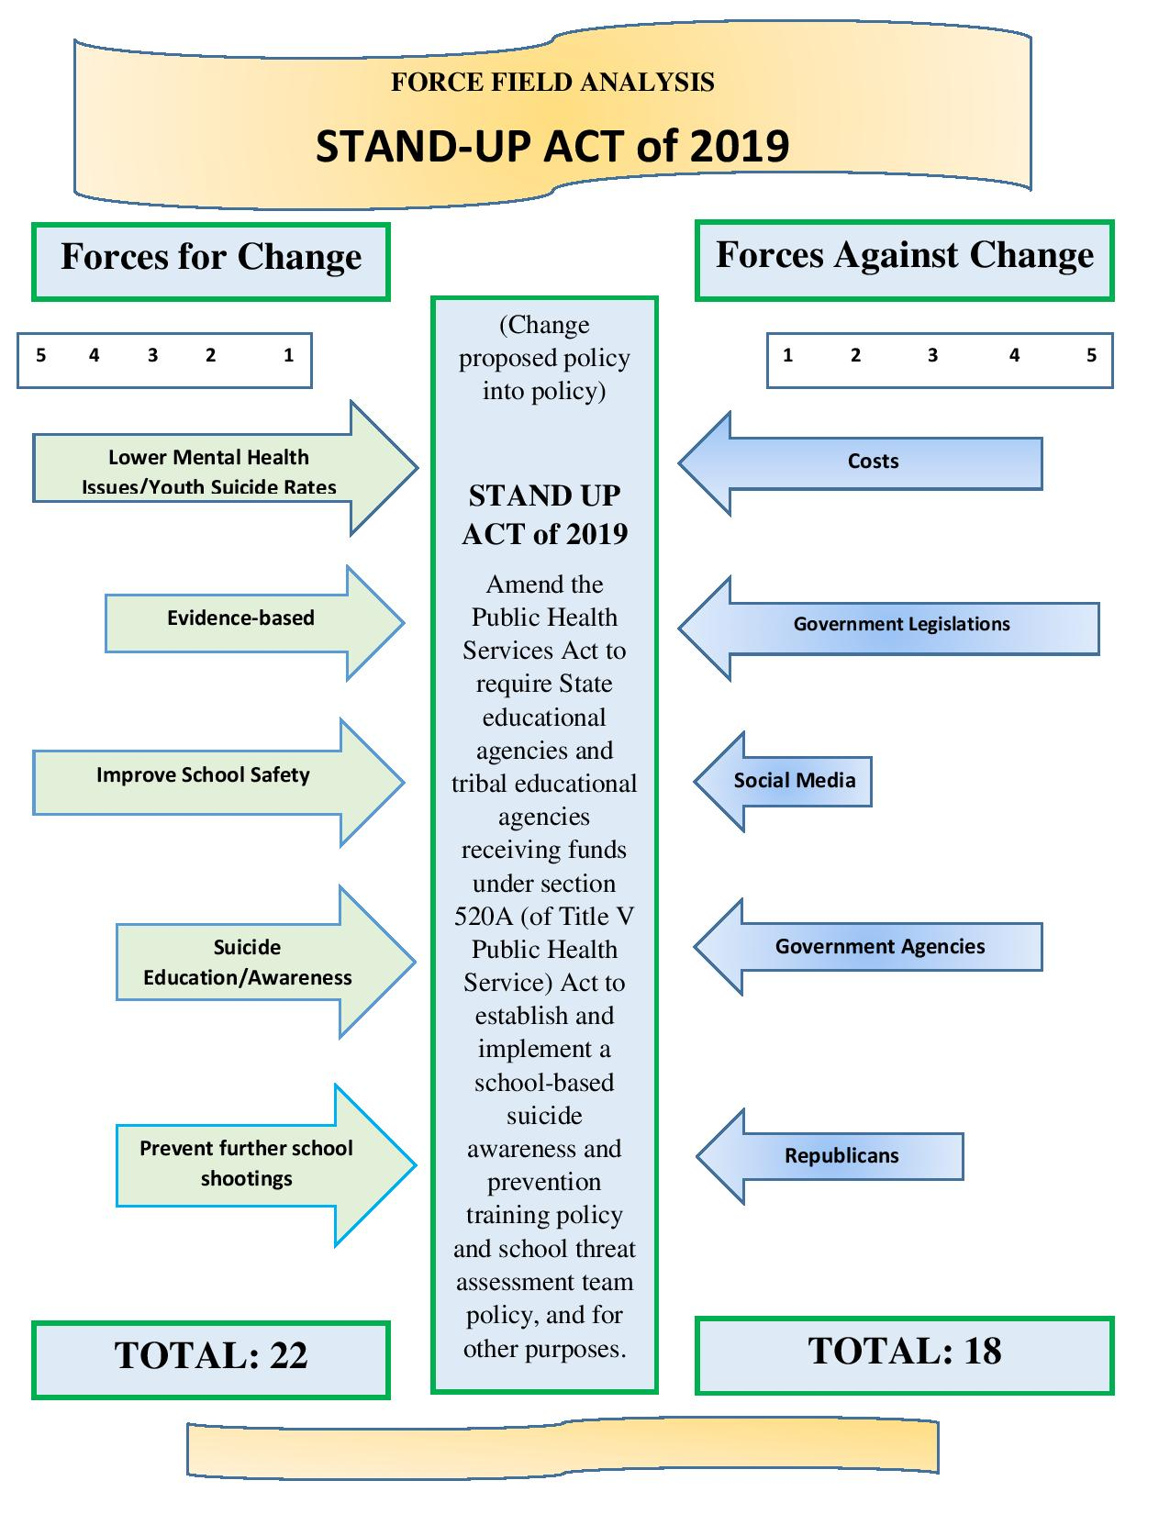
Appendix C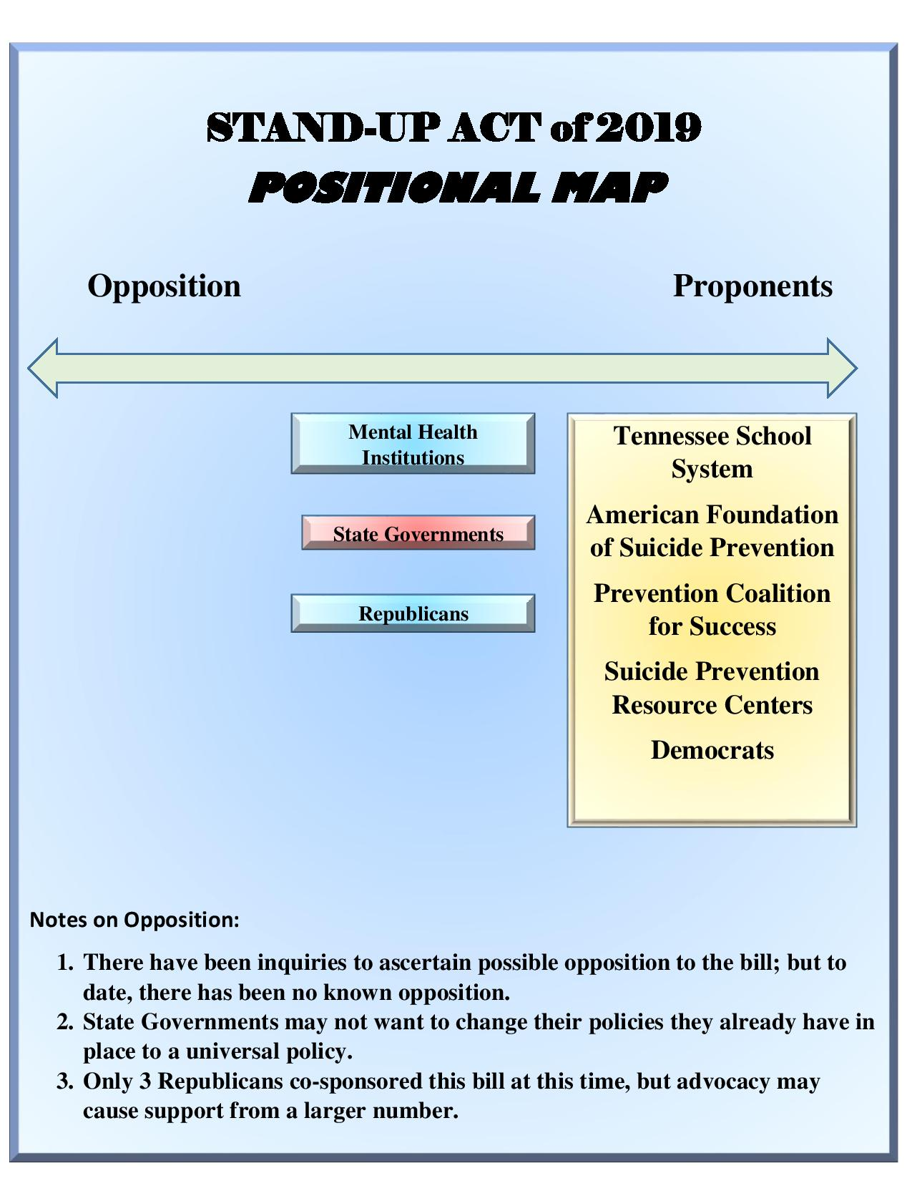

Appendix D
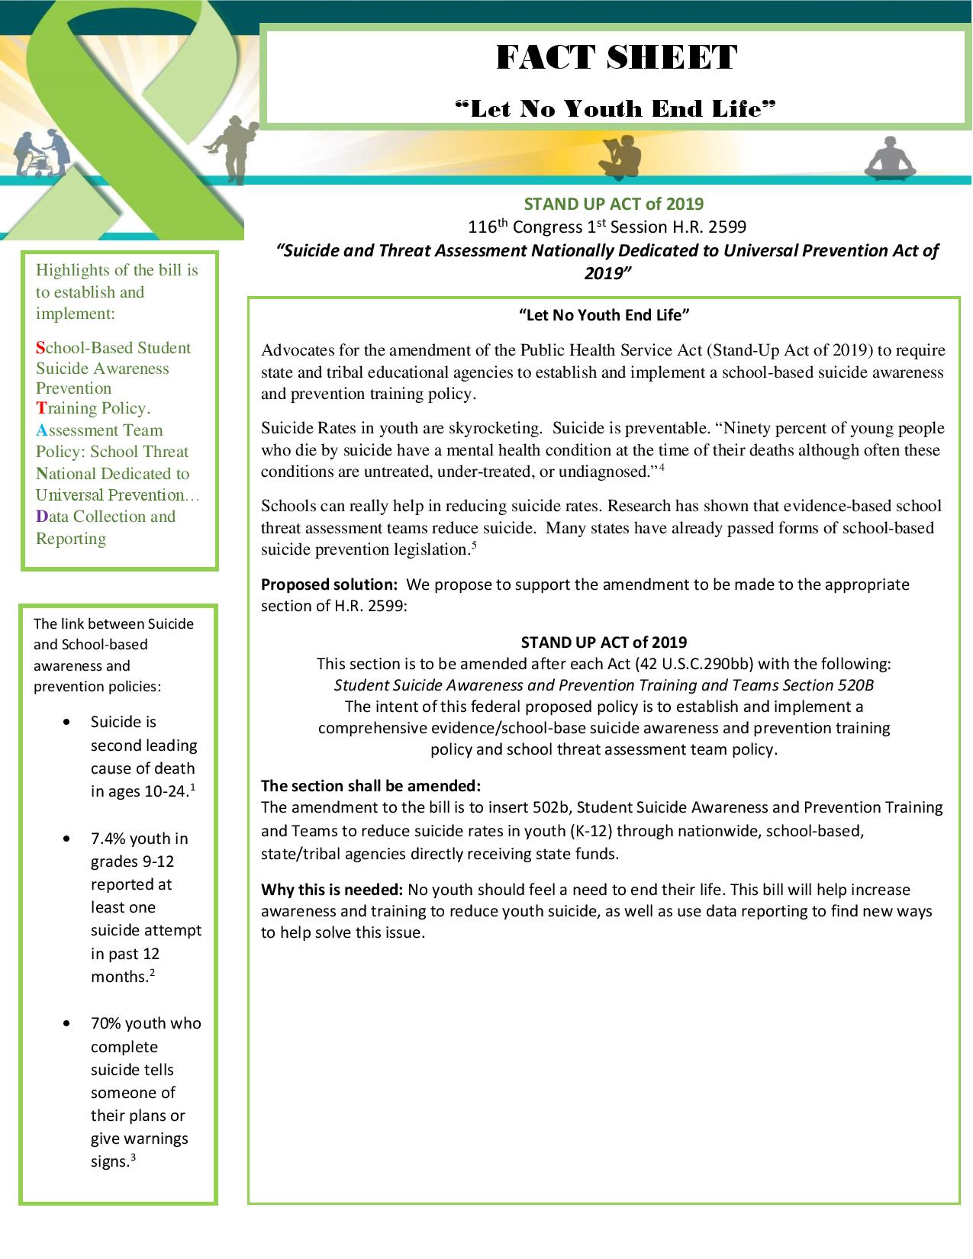
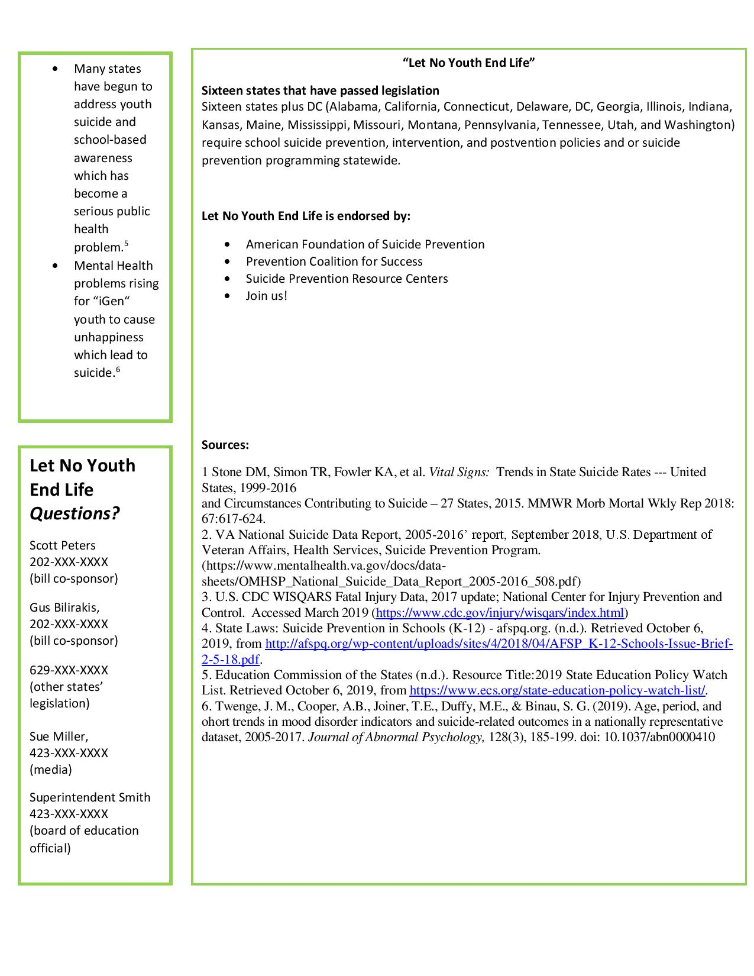

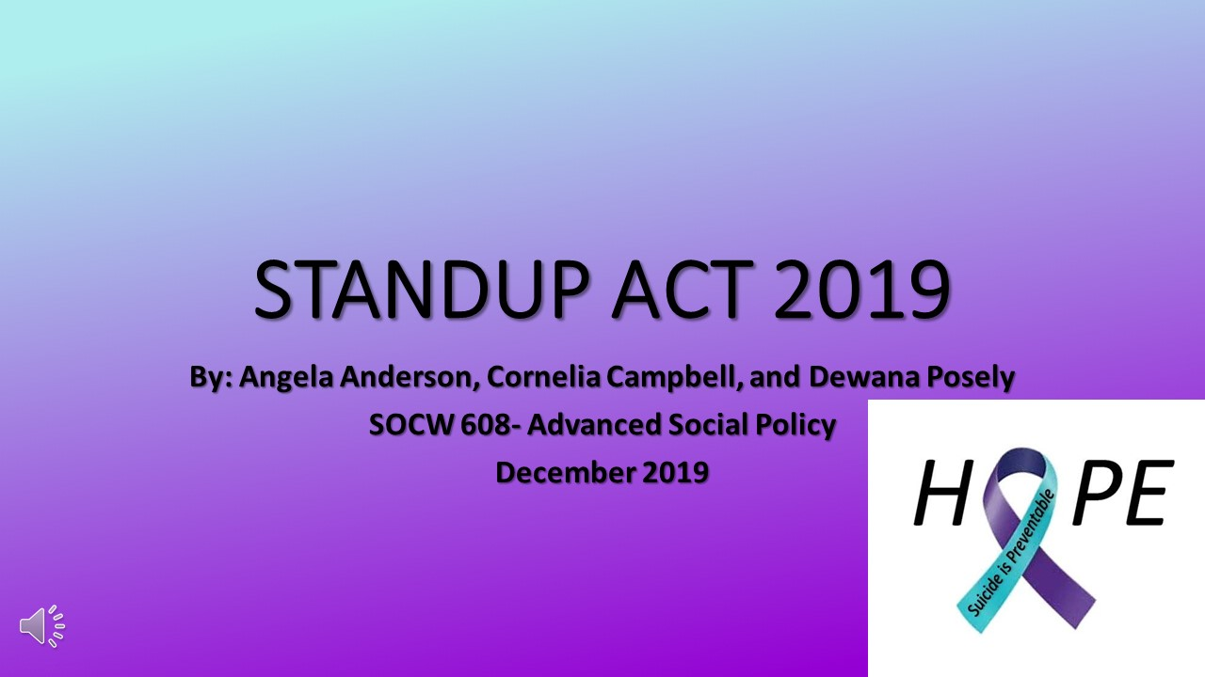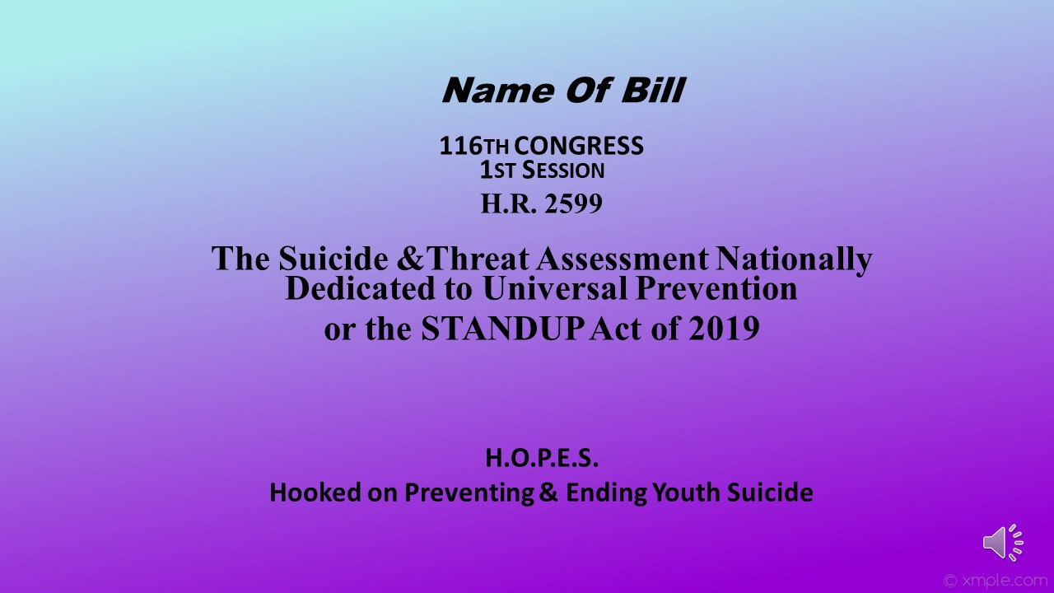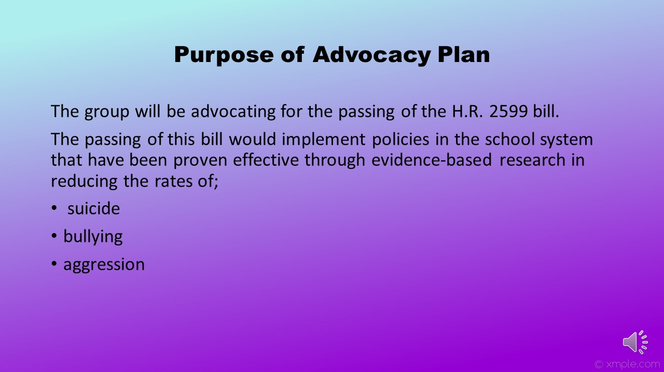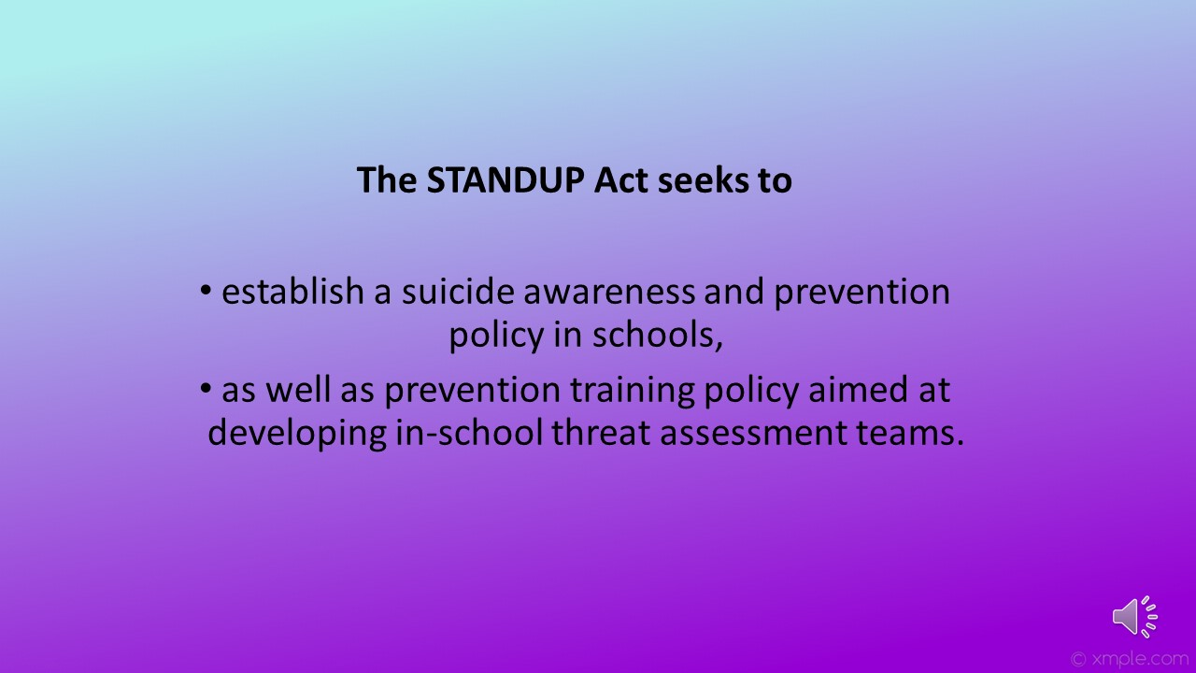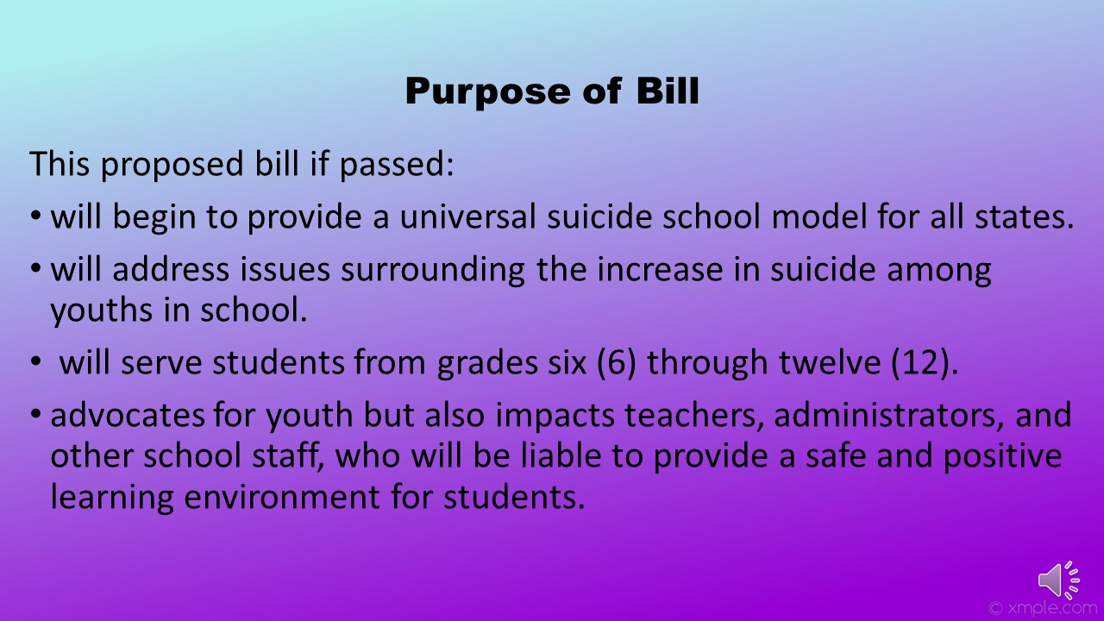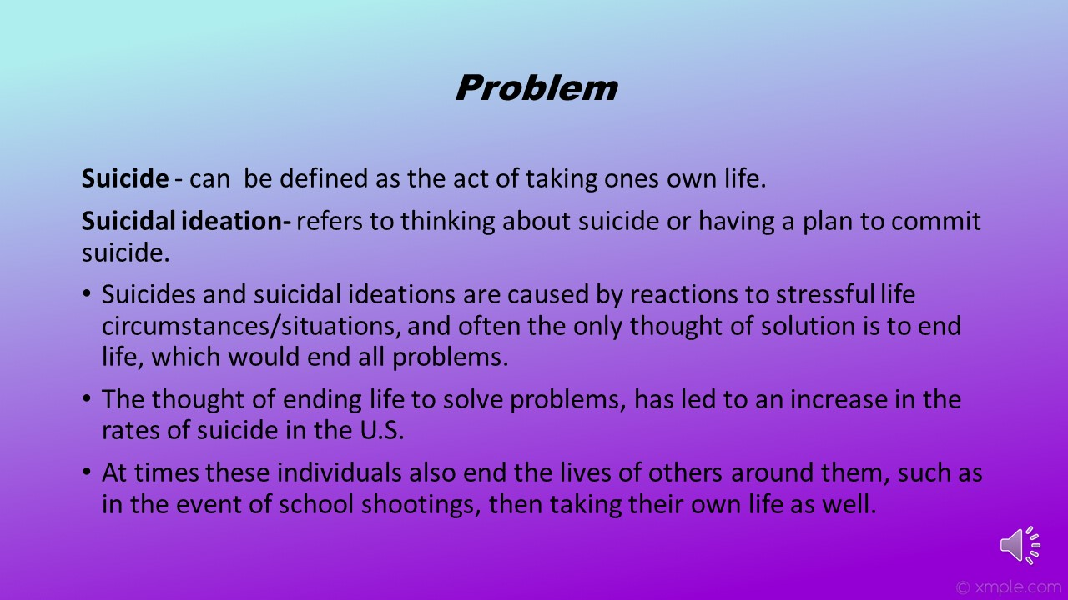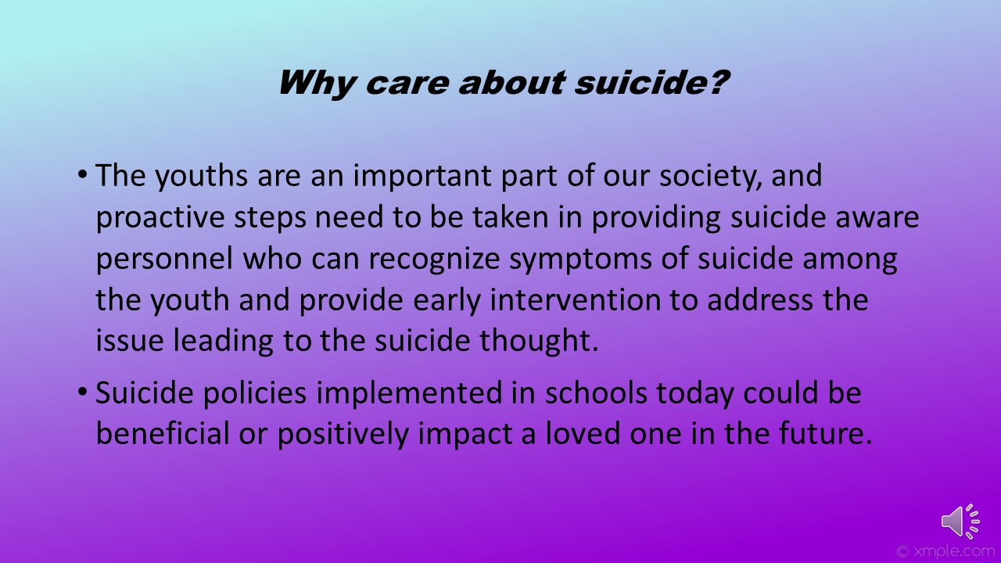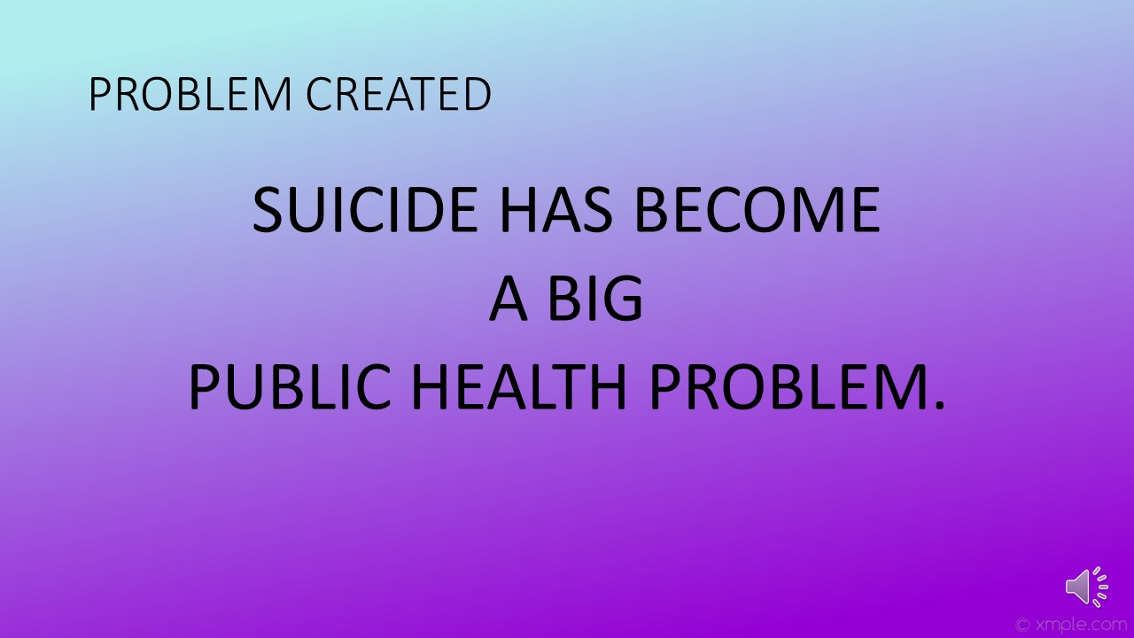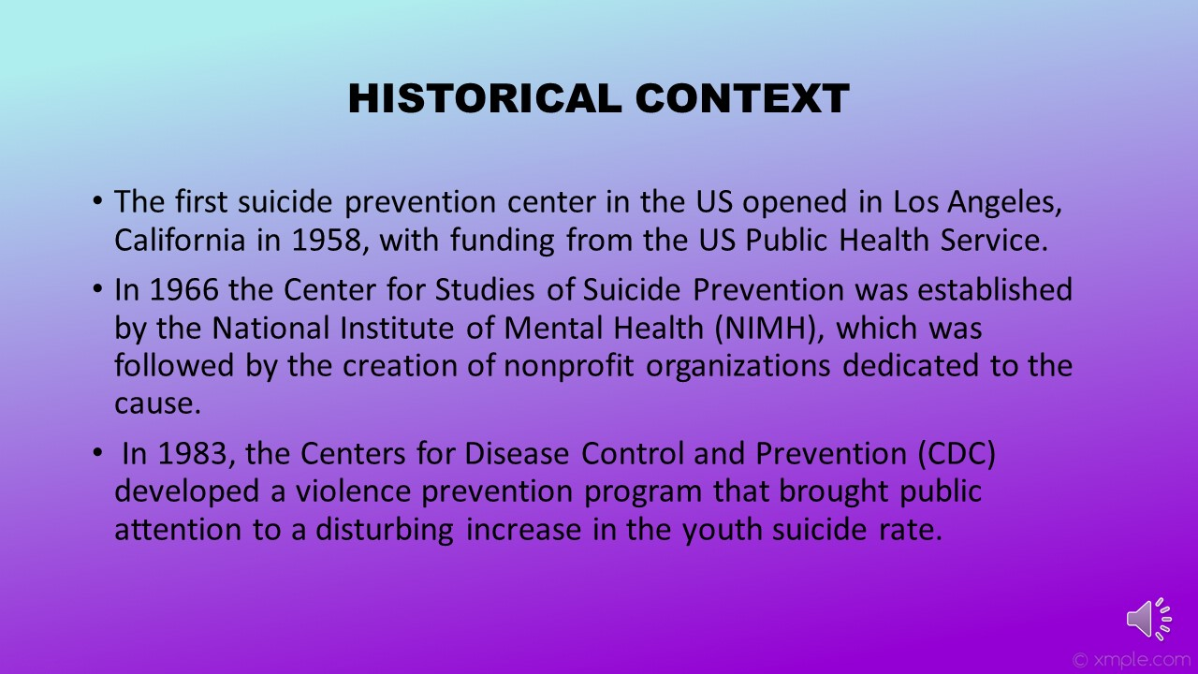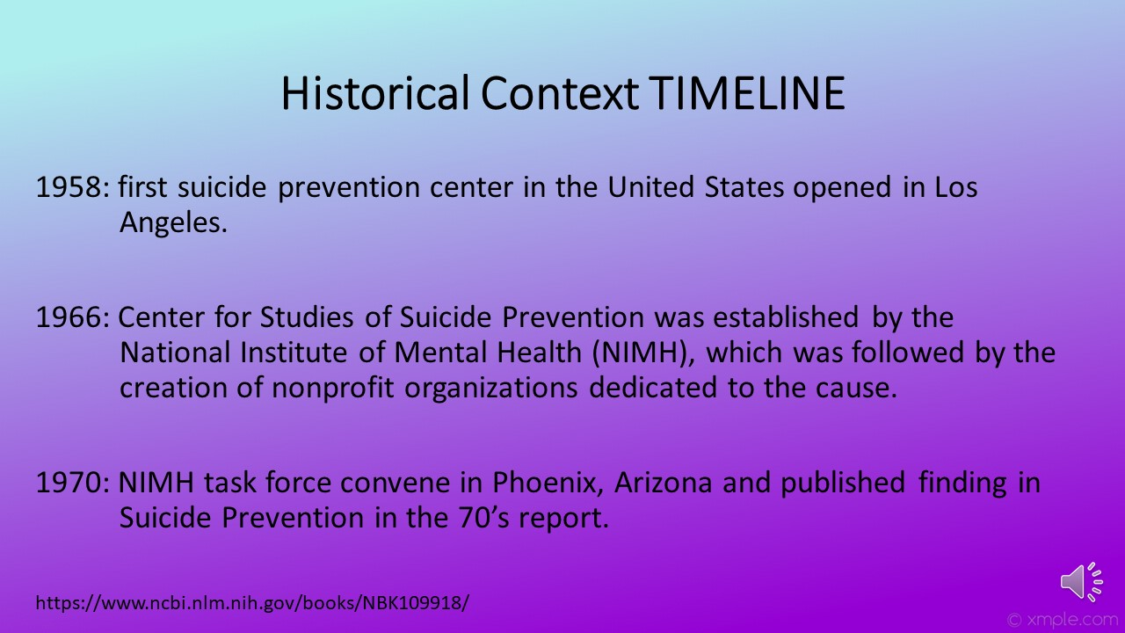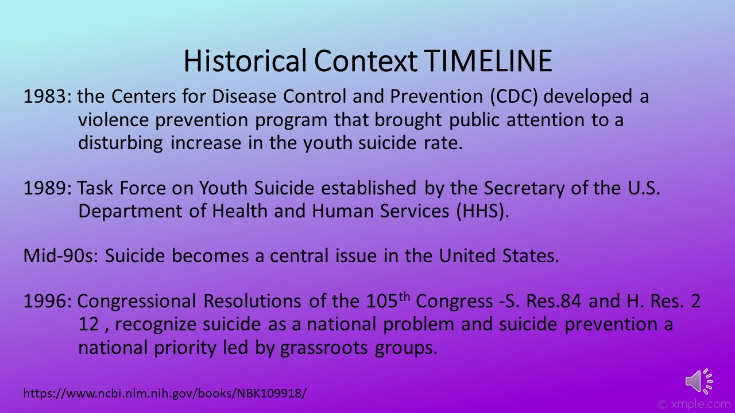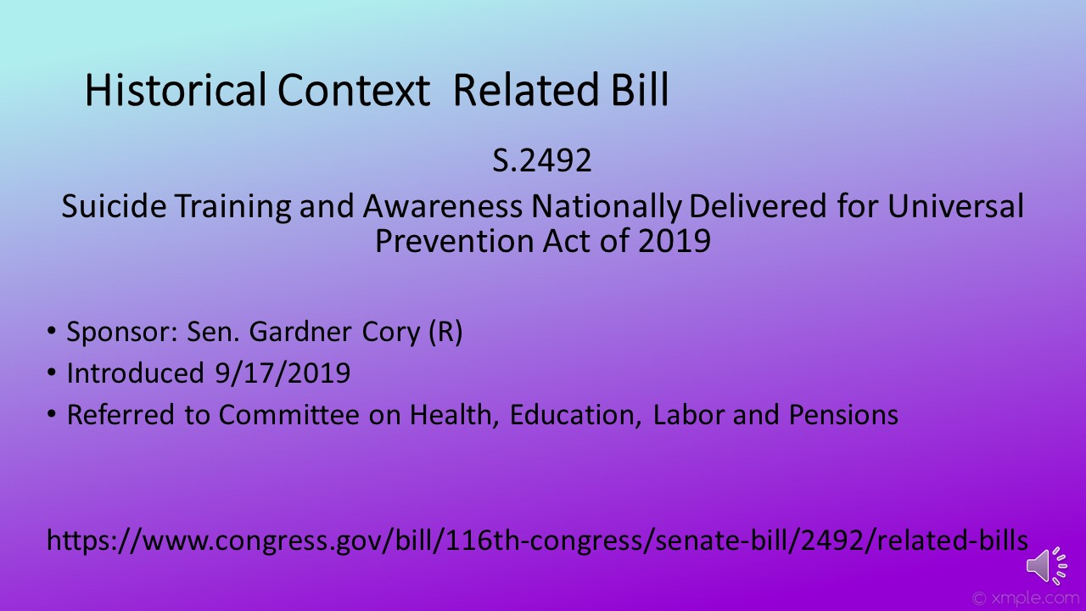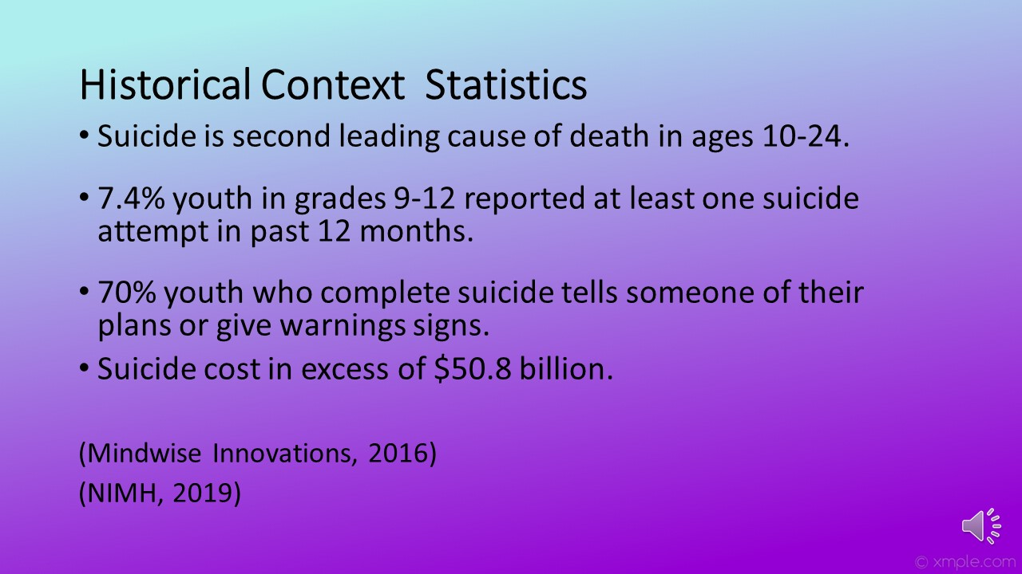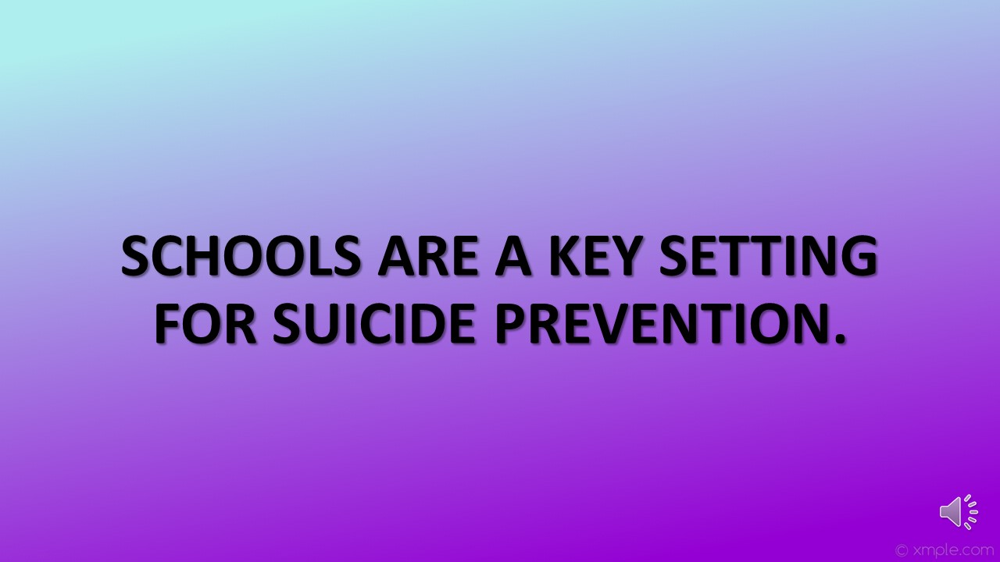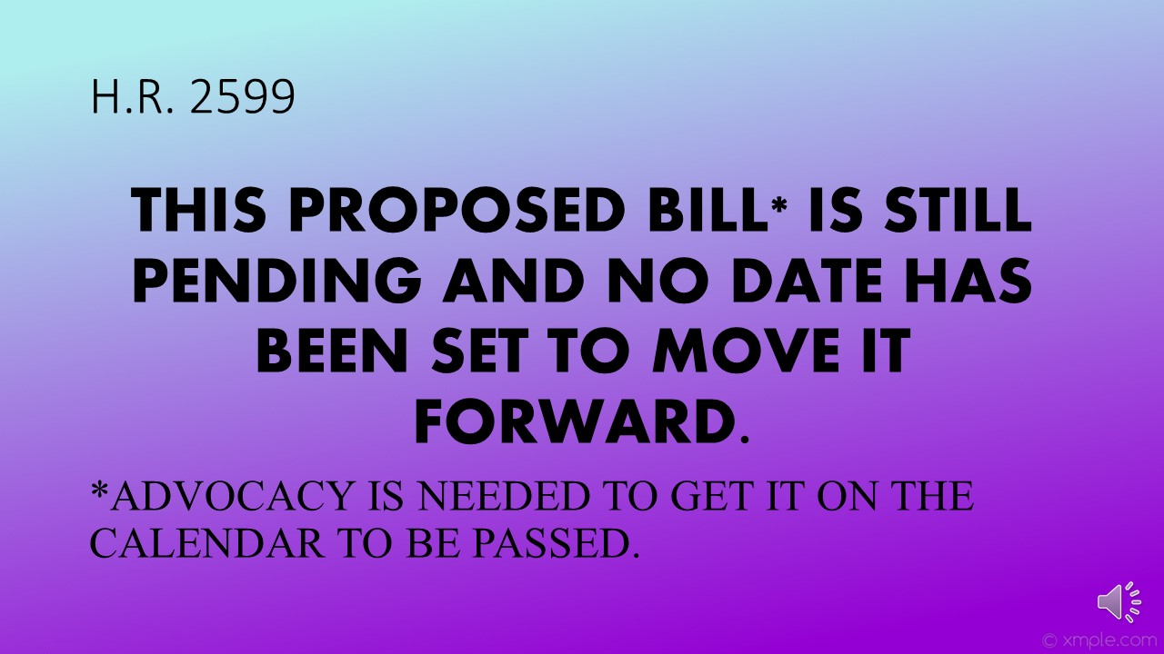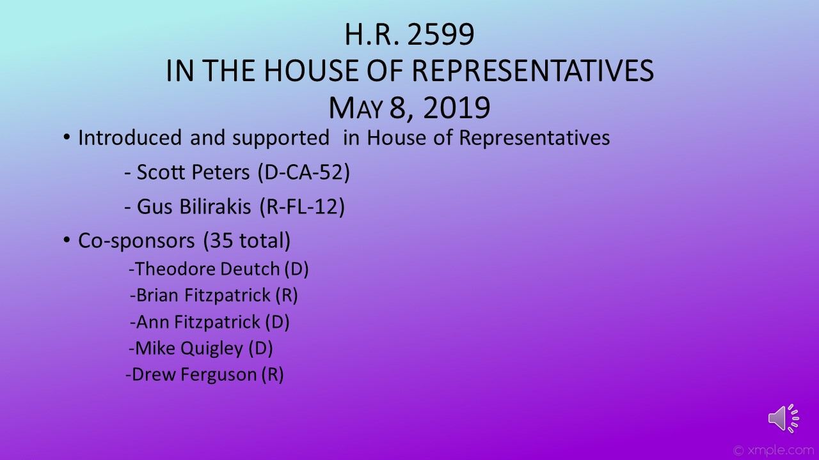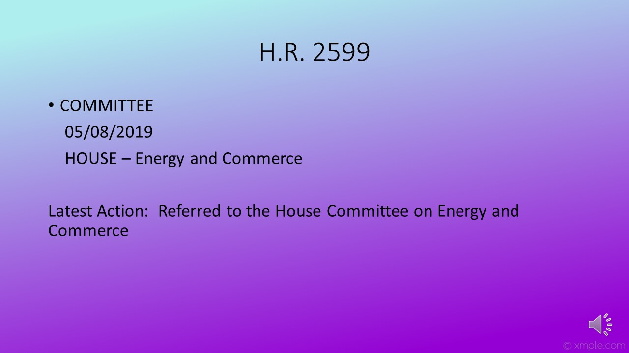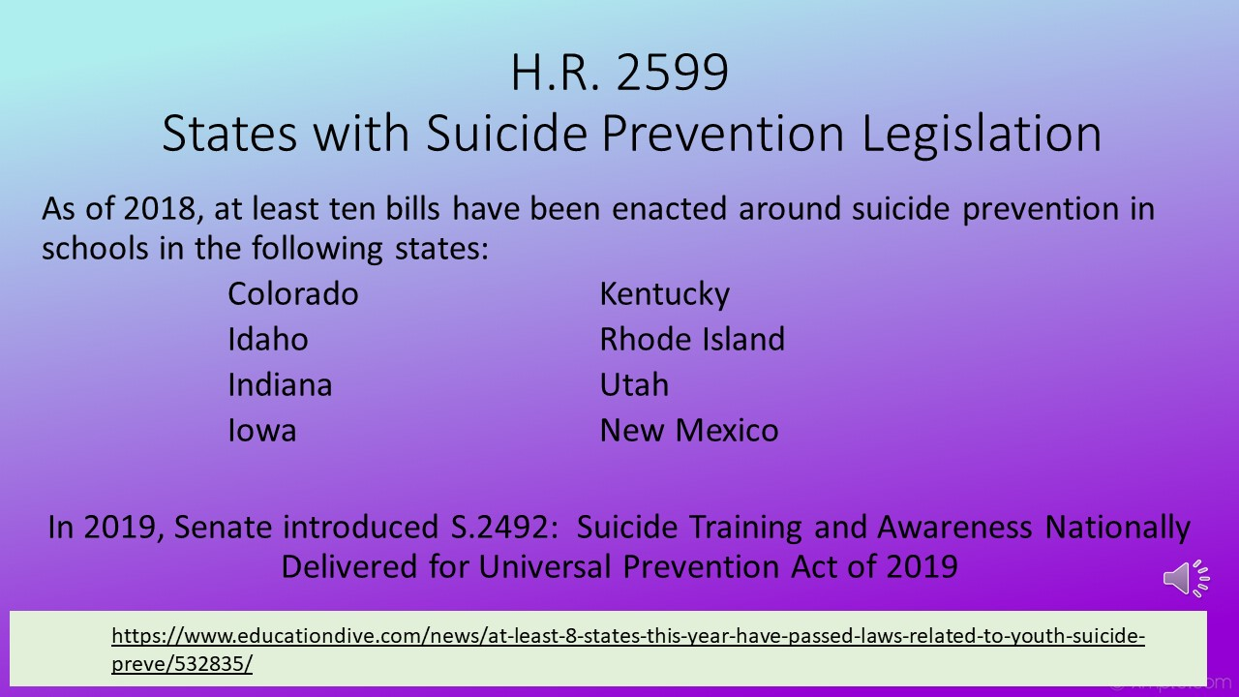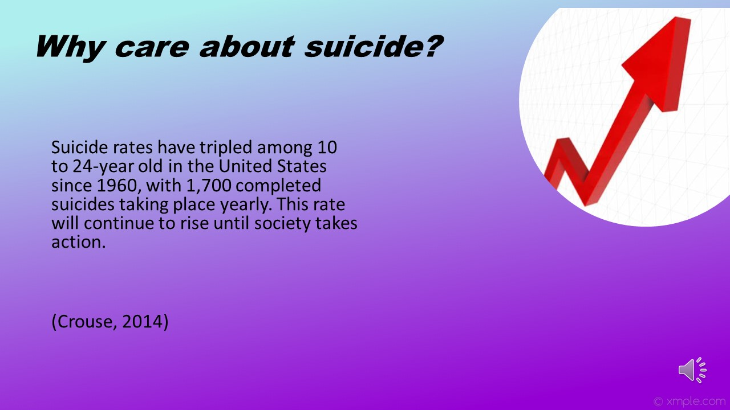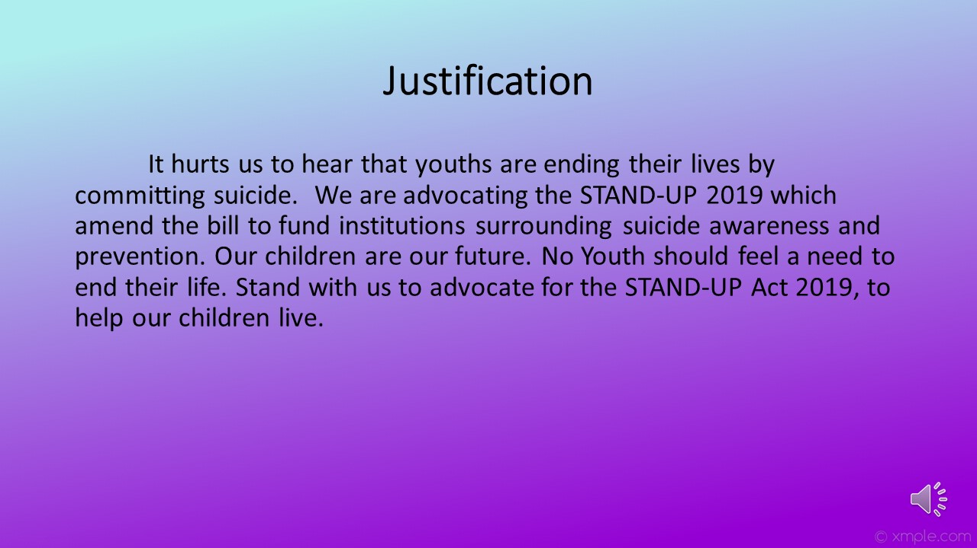

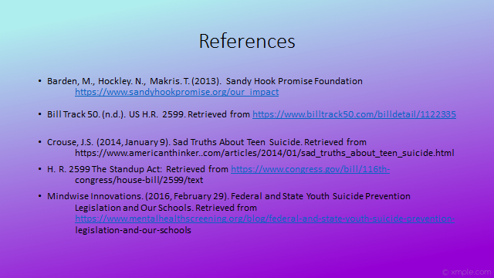
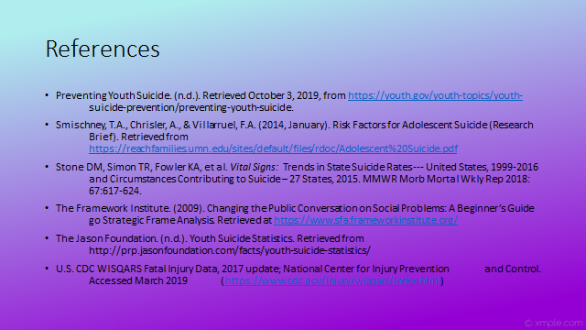
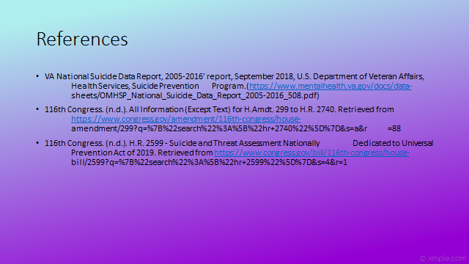

Appendix F

ELEVATOR SPEECH:

It hurts us to hear that youths are ending their lives by committing suicide. We are advocating for the STAND-UP Act of 2019 which amend the bill to fund institutions surrounding suicide awareness and prevention. Did you know that suicide is the second leading cause of death among youth 10 to 24 years old in the U.S? Our children are our future. No youth should feel a need to end their life. Why don’t you follow our Facebook page and stand with us to advocate for the STAND-UP Act 2019, to help our children live a normal healthy life.
The plan that will need to be implemented in order to monitor the issue would be to first fight repeal to ensure the bill is passed. Secondly, regulate the process to ensure the details of the bill are properly distributed. Lastly, oversee that this bill is and stays in compliance.

