Comprehensive Family Treatment Plan

Sydney Shaw

July 7th, 2024

Mental Health Emphasis I

Case Conceptualization

The client is Sasha Kyle and she is 13 years old. Sasha is having behavioral issues at school and home. Sasha has been sneaking out, using alcohol, and smoking marijuana, and having promiscuous behavior with older males. Sasha reported to her school counselor that she is upset about her mother getting remarried after her father died. Sasha feels like her mother has moved on and wants this “other” family and she is being left behind. The counselor recommended family therapy as well as individual therapy for Sasha. The counselor notified the mother and stated she is starting to show symptoms of borderline personality disorder however she did not want to diagnose her yet as therapeutic interventions may help with some of the behaviors and attachment issues she is currently experiencing.

Introductory Phase

The Kyle family consists of a mother and step – father, Mrs. Kyle and Mr. Smith, with two teenage daughters, Sasha Kyle and Stephanie Smith, that are 3 years apart. Mr. Smith and Mrs. Kyle are currently coming to therapy due to their daughters not getting along and having some delinquent behavior. Mr. Smith and Mrs. Kyle have been married for the past 5 years and each brought a teenage daughter to their current marriage. Mrs. Kyle’s child’s father is deceased. Mr. Smith’s child’s mother is currently in jail due to drug related charges.

During the initial assessment with the family, everyone was given an opportunity to introduce themselves and provide their perspective on their current family situation. The therapist went over confidentiality, provided space for them to create their own rules for the family sessions, and discussed the purpose for her involvement. The therapist completed an eco-map and family map with the family to help identify supports and strengths in their life as well as where the relationships are strong and some need improvement (Colapinto, 2019). A treatment plan is then developed with the family to hold their actions accountable during this time.

Subsystems

During the initial few family therapy sessions, it was observed that the family has a couple subsystem between Mrs. Kyle and Mr. Smith, the parental subsystem for Mrs. Kyle and Mr. Smith, child subsystem for Sasha and Stephanie, a stepsibling subsystem for Stephanie and Sasha, a parent-child subsystem between Mrs. Kyle and her daughter Sasha, and lastly Mr. Smith and his daughter, Stephanie. When observed on an analytical level, there are multiple unclear expectations within each of these subsystems and are therefore functioning in a problematic way. There is an ineffective parental hierarchy in place due to different parental expectations being brought to the new blended family system.

Boundary Assessment

The Kyles have brought different parenting styles to their new blended family. This has created some conflict within the family. Mr. Smith has allowed his daughter a lot more independence due to him not being able to meet her emotional needs. Stephanie has learned to rely on herself which has parentified her in a way and now has an avoidant attachment style with her family. Mrs. Kyle was the more relaxed and loving parent until her husband died. After he passed, Mrs. Kyle had to take on both roles of a caring and disciplinarian parent. Mrs. Kyle then tried to allow her new husband Mr. Smith to become the disciplinarian however this was new to him as his ex-wife used to be the disciplinarian. Due to the parents having rigid boundaries about their own respective parenting styles, it has created conflict within the family system.

Hierarchy

In regards to the hierarchy of the family, it appears the Mrs. Kyle and Mr. Smith are in the parental role. Stephanie was in the parental role with her father prior to his remarriage which has helped her require less attention from the parents than her step-sibling. Sasha is in the child subsystem isolated due to current behaviors and not having her needs met. The parental hierarchy is insufficient in terms at this time (Gehart, 2014).

Family Development

Mrs. Kyle and Mr. Smith met each other in their church. They had not interacted much before however Mr. Smith met Mrs. Kyle when she was leaving a widower support group. The developmental life stage the family is in is the families with school-age or adolescent children. Boundaries and expectations will need to be established in agreement between the parents due to their daughters becoming teenagers as well as prior to them leaving the home and becoming independent.

Strengths

The family is willing to seek help and understands the importance of addressing mental health needs. The family has community support through their church, friends, and work.

Needs

The family has difficulty implementing healthy coping skills and conflict resolution. Both subsystems of the Kyle’s and Smith’s have strained relationships with their extended families.

Working Phase

The treatment plan that was developed with the family was based on a Strengths-based model. Each family member was given tasks and goals to work on during their time in family therapy. The family was provided education on coping skills and how to handle future situations when conflict arises.

Interventions

During the working phase, various interventions were implemented with the family. An eco-map and family map were created with the family to provide a visualization of their current situation. Sasha completed an alcohol and drug assessment to gauge how dependent she has become on these substances. Sasha was allowed to complete alcohol and drug education during the CCFT treatment during the family therapy. Due to Sasha only using a few times and it was at the beginning stages, she was able to implement coping mechanisms to help her stop using illegal substances and find alternative and healthier ways to deal with negative emotions.

Termination Phase

Family therapy lasted for approximately nine months. The family was given the opportunity to report on what they felt went well during family therapy and if there were any other areas they would like to work on. Sasha was able to complete an alcohol and drug assessment and has not used alcohol or marijuana in the last three months. Sasha’s behaviors at home and school have decreased and she has found a place within her family system that meets her emotional and mental needs. The parents were able to sit down together and come up with agreed upon rules, boundaries, and expectations for their children. Afterwards, the parents then started implementing them to both daughters fairly and at first there was resistance however after some time, the girls accepted them and the family bond became stronger. The step-siblings started having a stronger bond once they were treated equally and gained a sense of sisterhood.

Eco-Map

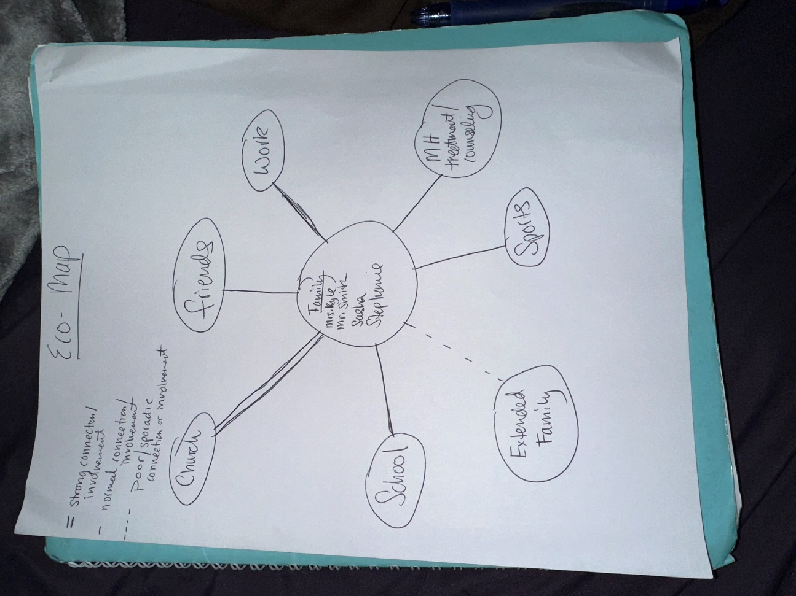

This eco-map was completed with the family. It shows that the family has strong connections and involvement in their church. They attend on Wednesdays and Sundays and also participate in other activities and events hosted by the church. This is where Mrs. Kyle and Mr. Smith met. The family reported having connections and support from their friends, work, and school. The children are in sports and are actively participating in mental health treatment/counseling.

Family Map

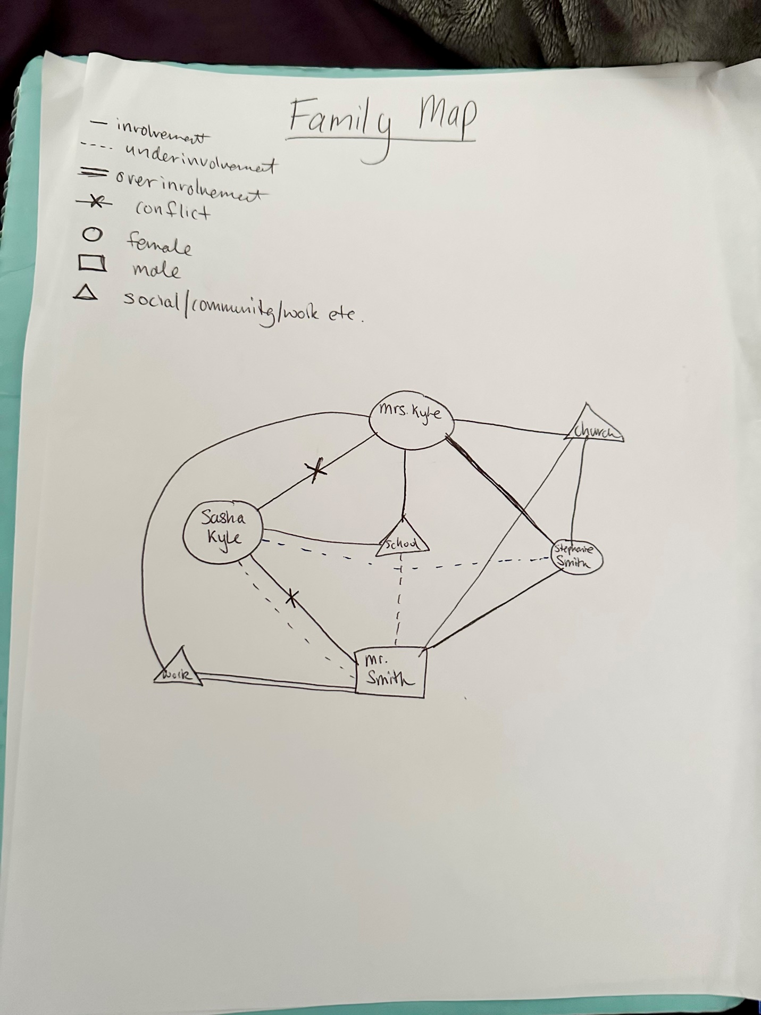

References

Colapinto, J. (2019). Mapping in structural family therapy. *Encyclopedia of Couple and Family*

*Therapy*, 1766–1767. https://doi.org/10.1007/978-3-319-49425-8_972

Gehart, D. R. (2014). Mastering competencies in family therapy: A practical approach to theory

and clinical case documentation. Belmont, CA: Brooks/Cole.